Recurring ACH Payment Authorization Form
You authorize regularly scheduled charges to your checking or savings account. You will be charged the amount indicated below each billing period. The charge will appear on your bank statement as an “ACH Debit.” You agree that no prior notification will be provided unless the amount changes, in which case you will receive notice from us at least 10 days prior to the payment being collected.

Please complete the information below:
I, (full name) __________________, authorize RetireeFirst, LLC or its affiliate, Labor First, LLC to charge my bank account on the 3rd of each month for payment of my health insurance plan in the amount of: $_________________.
Billing Address: |  | City, State  & Zip Code:
Phone Number:
Plan Start Date: |  | Plan Sponsor:

** A copy of a voided check or bank letter must be attached **
Account Type:  (Please check) | Checking Account: |  | Savings Account:
Name on Account: |  |  | Bank Name:
Account Number:
Bank City/State: |  |  | Routing # (9 Digits):
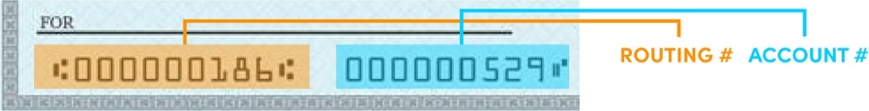

Signature: |  | Date:

I understand that this authorization will remain in effect until I cancel it in writing, and I agree to notify RetireeFirst, LLC in writing of any changes in my account information or termination of this authorization at least 15 days prior to the next billing date. If the above noted periodic payment dates fall on a weekend or holiday, I understand that the payment may be executed on the next business day. If withdraw is denied, an NSF Fee of $25 will be charged. In the case of an ACH Transaction being rejected, I understand that I will be responsible for a $25 fee and RetireeFirst may at its discretion attempt to process the charge again within 30 days and agree to an additional $25 charge for each attempt returned NSF Fee which may be initiated as a separate transaction from the authorized recurring payment. I also understand that without proper payment my account will be termed. Once you have received an NSF Fee or closed account fee three (3) times we will no longer pull your premium via ACH and you must pay for the year upfront in order to remain enrolled into your plan(s). I acknowledge that the origination of ACH transactions to my account must comply with the provisions of U.S. law. I agree not to dispute this recurring billing with my bank so long as the transactions correspond to the terms indicated in this authorization form.

