# BALTIMORE COUNTY PUBLIC SCHOOLS OPEN ENROLLMENT

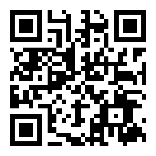

BCPS Benefits Open Enrollment 2024 for retirees will be held **October 16 - November 10, 2023.** If you are satisfied with your current benefits, **do not take any action.** Your current coverage will automatically be renewed for the coming year. To make changes, please call RetireeFirst at **(443) 290-3114 (TTY 711) or Toll Free (833) 550-1676 (TTY 711)** beginning **October 16 through November 10, 2023.**

**\*\*New for 2024**  
You will not have the opportunity to make changes to your coverage until the next open enrollment period, unless there is a qualified life event(marriage, birth/adoption, loss of coverage, etc.)**

You will receive an enrollment guide directly from RetireeFirst in October. If you would like to access the Enrollment guide online, beginning October 1st, scan the QR code to the left.