Tips to Reduce Drug Cost
Convenient Patient Portal
Use the QR code below or visit app.savrx.com/login to use our secure patient portal!



Talk with Your Doctor about Cost
Let your doctor know that cost and therapeutic effectiveness both matter. Ask if there is a generic or lower-cost substitute available.



Review Medications Every Six Months
Eliminate unnecessary drugs (and lower your risk of side effects and drug interactions) by reviewing medications with your physician or pharmacist.



Ask for Smaller Amounts of New Meds
Consider asking your doctor for a smaller quantity of a new medication until you know it is right for you.



Shop around and Compare Prices
Look in supermarket pharmacies, chain pharmacies, independent pharmacies, and Sav-Rx mail order pharmacy.



Ask your Pharmacist for Guidance
Pharmacists can be helpful in guiding you and identifying other options if you are unable to afford your medications.



Call Sav-Rx at 800-545-2810
Call Sav-Rx for assistance in reducing your overall drug costs. There are live representatives available to take your call 24 hours a day, 7 days a week, and 365 days a year.




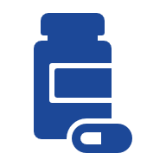
NECA-IBEW Family Medical Care Plan

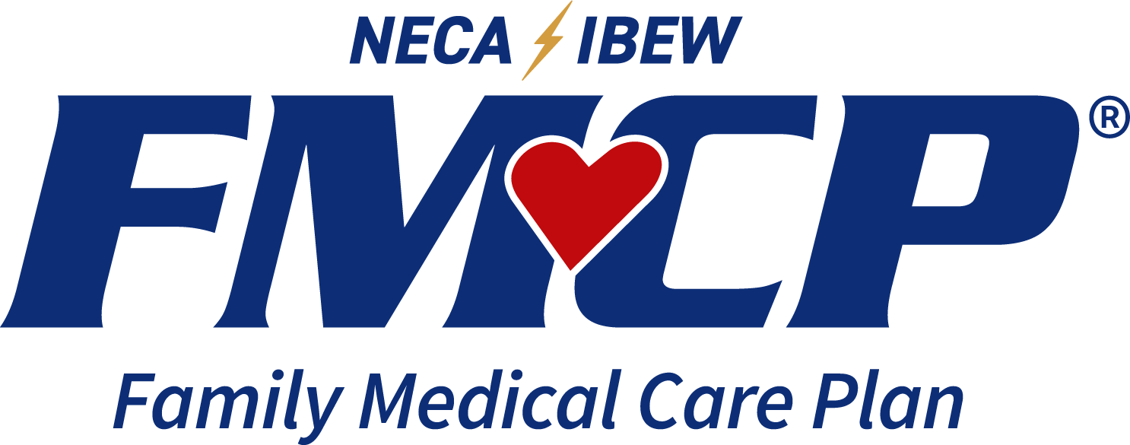
Call 800-545-2810
To speak at any time 24/7/365 with a live, Sav-Rx Union representative

For all other plan questions please call RetireeFirst at:
1-855-220-9437

For more information, visit www.savrx.com
Secondary Prescription Drug Plan
Administered by:

Use the Portal to:
- View prescriptions on file
- Order multiple refills at once
- Download your claims history
- View current order status
- Track your orders
- Update your profile and method of payment
- Download and see an electronic ID Card.
- Receive Mail Order notification when your refills are due!
800-545-2810

Medication Coverage
Your Prescription Benefit
Where to Use Your Benefit

Retail Pharmacy
Generic | $0
Formulary Brand | 20%
Non-Formulary Brand | 30%  (Min. $40)
Brand w/Generic | $0 + Diff in Cost
Sav-Rx Mail Order & Walk-In Mail Order
Generic | $0
Formulary Brand | 20%
Non-Formulary Brand | 30%  (Min. $40)
Brand w/Generic | $0 + Diff in Cost

Maximum Out of Pocket
Individual | $1,000
Family | N/A
Deductible
Individual | N/A
Family | N/A

- Coordination of your benefits will result in
these copays.

- This Sav-Rx Secondary Prescription Drug Plan works with the UnitedHealthcare Primary Prescription Drug Plan to assist with some expenses not covered by the primary plan.

- The Sav-Rx Plan is secondary coverage.

- To access the benefit, present both your
UHC Primary ID card and Sav-Rx Secondary ID card at the pharmacy.

Sav-Rx Retail Pharmacy Network:
How to Make Use of the Network
- Present your card at any of over 72,000 retail network pharmacies nationwide to purchase your prescription medication.
- To locate a pharmacy near you, visit www.savrx.com and enter the Group on your ID card and your zip code.
- Walmart and Sam’s Club are not included in this Union friendly network.
- To access the benefit, present both your Sav-Rx and UnitedHealthcare ID cards at your pharmacy.




800-545-2810

- Most maintenance medications are covered by your plan. It is important to note that any medications covered by your primary UnitedHealthcare (UHC) benefit will be covered through this secondary prescription benefit.
- Certain products are excluded from prescription coverage. Medications not covered under your primary UHC benefit will be excluded from coverage under this secondary prescription benefit, unless they were previously covered under your union plan.
- Some medications may be subject to quantity limitations or require prior authorization for coverage.
- Please refer to your Summary Plan Description for specific coverage rules.

For Organized Labor,
By Organized Labor
Sav-Rx Mail Order Pharmacy:
Benefits
- Cost-effective option for long-term maintenance and specialty medications.
- All orders shipped directly to your door for no additional charge!
How It Works
- Send in prescription
- Pay at the time of order
- Orders shipped to you
- Convenient refills by phone, the Sav-Rx website, or the Sav-Rx App
How to Send in Prescriptions (3 Options)
- Ask your doctor to send the prescription electronically to Sav-Rx in Fremont, NE.
- Ask your doctor to fax us the prescription at 402-753-2890.
- Call Sav-Rx with your prescription drug names and your physician’s contact information, and we will do the rest!

