
2026 – University of Denver Medicare Advantage with Prescription Drug Plan (MAPD)

Your Dedicated Advocacy Phone Numbers

(720) 770-0677 (TTY 711) or toll free (855) 423-3275 (TTY 711)

Frequently Asked Questions

Plan Design
Medical Carrier:

Medical |  | You pay
Deductible |  | $0
Office Visit: Primary Care |  | $15
Office Visit: Specialist |  | $25
Inpatient Hospital |  | $300 Per admission
Outpatient Surgery |  | $100
Skilled Nursing Facility |  | $0 (Days 1-100)
Emergency Room |  | $65 Waived if admitted
Urgent Care |  | $15
Ambulance Services |  | 20% (Up to $195 per trip)
Lab Services |  | $0
Radiology Services |  | - $0 X-rays  - $100 Specialty Scans (Including MRI and PET)
Durable Medical Equipment |  | 20%
Preventative Screenings |  | $0
Chiropractic |  | $15 (20 Visits per year)
Acupuncture |  | $15 (20 Visits per year)
Hearing |  | - $15 Routine hearing exam  - Hearing aid credit of up to $1,000 per ear, every 3 years
Vision |  | - $15 Eye exam  - Eyewear (lenses and frames) allowance of up to $200, every 2 years
Fitness Benefit |  | One Pass™ Fitness

Prescription Carrier:

Prescription | 30-Day Retail  You Pay Up To | 90-Day Mail Order  You Pay Up To
Tier 1 Preferred Generic | $5 | $0
Tier 2 Non-Preferred Generic | $15 | $0
Tier 3 Preferred Brand | $40 | $80
Tier 4 Non-Preferred Brand | $60 | $120
Tier 5 Specialty | $60 | $120
Note: CMS caps the 30-day supply cost for Insulin medication at $35.
Costs for a 30-day supply may be less but will not exceed $35 for 2026.

Plan Questions

- How do I enroll?
To continue your enrollment into the plan, the enclosed ACH Form needs to be completed and returned to RetireeFirst in the included pre-paid envelope. You will be automatically re-enrolled into the University of Denver’s Kaiser Permanente Senior Advantage (HMO) Group Plan with Part D. You will also be automatically re-enrolled into the EyeMed Vision Plan and/or Delta Dental Plan for the 2026 plan year if you were enrolled into vision and/or dental for 2025. If you would like to make any changes for the 2026 plan year, please contact RetireeFirst at
(720) 770-0677 (TTY 711) or toll free (855) 423-3275 TTY 711).

- How much do I have to pay for the plan?
Your premiums will be handled by RetireeFirst starting January 1, 2026.
Plan Name | 2026 Monthly Premium Rates  (Per Household)
Kaiser Permanente Senior Advantage (HMO) Group Plan with Part D | $
EyeMed Vision Plan | $
Delta Dental Plan | $
Total Monthly Premium Rate Due | $

- Who do I call if I need assistance with the plan?
Advocacy and retiree support will continue through Gallagher, along with expanded assistance available through RetireeFirst for basic plan and billing questions. Gallagher Health Advocates can be reached at (866) 799-2725. The dedicated University of Denver Retiree Advocacy Team at RetireeFirst can be reached at (720) 770-0677 (TTY 711) or toll free (855) 423-3275 TTY 711).

Medical Questions

- Is there a medical deductible?
No, there is no medical deductible.

- Are there co-insurance or copays?
Yes, there is a cost share associated with this plan for some medical services. Please refer to the medical benefit chart on pages 1-2 of this document to better understand the medical co-insurance and copays.

- Does this plan require referrals?
Yes, this plan requires referrals.

- Does this plan require pre-certifications?
Some services may require pre-certifications.

- Does this plan have a network?
Yes, this plan has a network. For assistance confirming your providers’ participation in the Kaiser Permanente network or finding a new provider in network, please contact Gallagher Health Advocates at (866) 799-2725.
- Can I go to my current providers?
You can continue to see any provider that is in the Kaiser Permanente network.

- Do I still use my Medicare card?
No. Put your Medicare card in a safe place in case you need it later. You will only use your Kaiser Permanente ID Card for medical and prescriptions.

- What if my provider says they do not accept this plan?
Your provider must be in network with Kaiser Permanente for you to receive care.

Prescription Questions

- Is there a prescription deductible?
No, there is no prescription deductible.

- Are there co-insurance or copays?
Yes, there is a cost share associated with this plan for prescriptions drugs. Please refer to the prescription benefit chart on page 3 of this document to better understand the prescription copays.

- Are my prescriptions covered?
Most likely, yes. The prescription list is a comprehensive formulary just as before. Please call Gallagher Health Advocates at (866) 799-2725 if you need help looking up your prescriptions.

- Can I go to the same retail pharmacy?
Most likely, yes. You will continue to be able to use Kaiser Permanente participating pharmacies.

- Is there a mail order pharmacy?
There is a mail order pharmacy called Kaiser Permanente Mail Order Pharmacy which can be reached at 1-866-523-6059 (TTY 711). You can also call Gallagher Health Advocates at (866) 799-2725 with questions about mail order prescriptions.

- Will my prescriptions transfer from the old plan?
If you use a participating retail pharmacy, and have refills remaining, you do NOT need to obtain new prescriptions. If you use mail order, you may need to obtain new prescriptions from your provider if you are not currently using mail order.

- Can I still go to the Veterans Affairs (VA) for my prescriptions?
Yes, if you obtain some prescriptions from the VA, you may continue to do so. Please note that this is a separate benefit.

- Do I need prior authorizations for certain prescription medications?
Some prescriptions may require a prior authorization. Please contact Gallagher Health Advocates at (866) 799-2725 if you have questions or need assistance with prior authorizations as well as any other requirements, such as step therapy, quantity limit, or formulary exceptions.

- What is the catastrophic phase and is there coverage?
The catastrophic phase is a phase of coverage designed to protect you from having to pay very high out-of-pocket costs for prescription drugs. It is the final phase in your prescription drug plan and your copays will be $0. You will remain in this phase for the rest of the plan year. This coverage phase kicks in when you reach a true out of pocket total of $2,100 for prescription drugs. Keep in mind, lifestyle and non-part D prescription drugs do not count toward your out-of-pocket total.

Kaiser Permanente Senior Advantage (HMO) Group Plan with Part D Card Sample:

Front: Back:
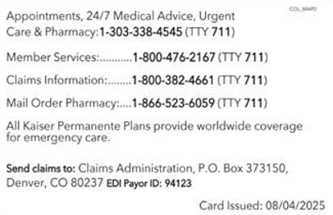
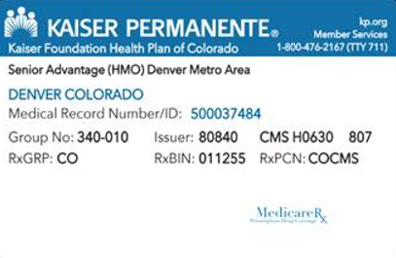

Disclaimer: For complete benefit details please refer to the carrier issued materials. This document includes a simplified summary of benefits and does not create any contractual rights.

