2022 – Sheet Metal Workers Local 19 Medicare Eligible Anthem Blue Medicare Advantage (PPO) Medical Coverage & Express
Scripts Medicare Prescription Drug Plan (PDP).
Frequently Asked Questions (FAQ)

GROUP BLUE MEDICARE ADVANTAGE PLAN
PLAN DESIGN

MEDICAL | YOU PAY
Medical Deductible | $0
Medical Maximum Out-of-Pocket | $0
Primary Care and Specialist Visits | $0
Inpatient Hospital Care | $0
Outpatient Surgery | $0
Skilled Nursing Facility | $0, Days 1-365
Urgent Care Center | $0
Emergency Room | $0
Ambulance | $0
Podiatry | $0, 12 Visits per year
Vision Services | $0 Routine Eye Exam per Year and $100  Allowance for Materials Every 2 Years
Routine Hearing | $0 Per Year, $70 Maximum Benefit
Hearing Aid Allowance | $500 Every Year
Silver Sneaker Fitness Benefit | INCLUDED WITH MA

Carrier
Prescription | 30-day Retail Member Pays up to | 90-day Retail Member Pays up to | 90-dayMail Order Member  Pays up to
Annual Deductible $0
Tier 1 Generic | $10 | $20 | $20
Tier 2 Preferred Brand | $15 | $30 | $30
Tier 3 Non-Preferred Brand | $30 | $45 | $45

- Will I be receiving new ID cards?
PLAN QUESTIONS
Yes, you will be receiving a new Anthem and Express Scripts card. You should begin using both your Anthem and Express Scripts cards on the effective date of your new plan.

Can I stay on my current plan?
No. All Medicare eligible retirees and/or dependents must change over to this plan.

What do I do if I lose or misplace my ID card?
Please call Labor First at 215-614-5385 or Toll Free 833-265-8653 (TTY711) and we will obtain a new one on your behalf, mail you a temporary card, and call your pharmacy/providers if needed.

MEDICAL QUESTIONS

Is there a Part A and/or Part B Deductible?
No you do not have a deductible.

Is there Co-insurance or Copays?
No you do not have Co-insurance or Co-pays.

Does this plan require referrals?
No, your plan does not require referrals.

Does this plan require Pre-certifications?
Some services may require Pre-certification. If you need assistance, please call your dedicated advocates at 215-614-5385 or Toll Free 833-265-8653 (TTY711) so they may assist you.

Does this plan have a network?
Yes, this plan has In and Out of Network benefits where you pay the same amount.

Can I go to my current providers?
You can see any willing Medicare provider.

Do I still use my Medicare Card?
No. Put your Medicare card in a safe place in case you need it at a later date. You will use only your Anthem ID Card for Medical and Express Scripts card for Drug. You will continue to use your Medicare card for obtaining the free over-the-counter COVID-19 tests.

What if my Provider says they do not accept this plan?
If your provider accepts Medicare, they will be paid by the plan whether they are considered in or out of network. Please call Labor First at 215-614-5385 or Toll Free 833-265-8653 (TTY711) to assist. We can reach out to your provider to explain.

Is there a Prescription Deductible?
PRESCRIPTION QUESTIONS
NO. You do not have a deductible.

Are my drugs covered?
Most likely yes, the drug list is a Comprehensive Formulary. Please call Labor First at 215-614-5385 or Toll Free 833-265-8653 (TTY711) if you need assistance looking up your drugs.

Can I still go to the VA (Veteran Affairs) for my drugs?
Yes. If you obtain some drugs from the VA, you may continue to do so.

Do I need Prior Authorizations for certain prescription medicines?
Some drugs may require a Prior Authorization. Please contact Labor First at 215- 614-5385 or Toll Free 833-265-8653 (TTY711) if you have questions or need assistance with Prior Authorizations as well as any other requirements such as Step Therapy, Quantity Limit, or Formulary Exceptions.

Anthem Card Sample:

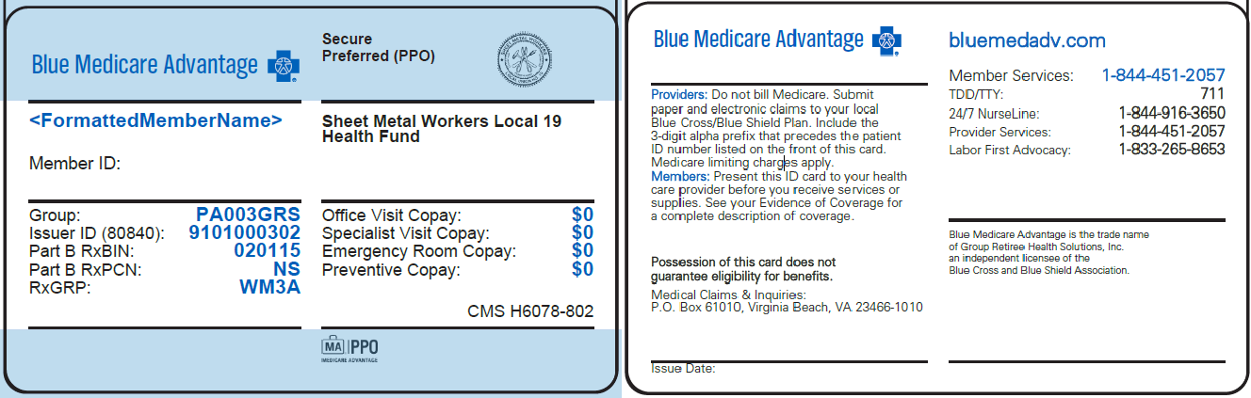
Front: Back:

Express Scripts Card Sample:
Front:
