GROUP MEDICARE ENROLLMENT MANUAL

Baltimore County Public Schools

Ver 9-23
(443) 290-3114 (TTY 711) or toll free (833) 550-1676 (TTY 711) 1

“I feel lucky that I can afford my medication and have the RetireeFirst options.”
-BCFPE (Health) Retiree

2024 Open Enrollment Information
Baltimore County Public Schools (BCPS) 2024 Benefits Open Enrollment will be held from Monday, October 16, 2023, through Friday, November 10, 2023.

**New for 2024**
You will not have the opportunity to make changes to your coverage until the next open enrollment period, unless there is a qualified life event (marriage, birth/adoption, loss of coverage, etc.)

3
(443) 290-3114 (TTY 711) or toll free (833) 550-1676 (TTY 711)

Group Medicare Enrollment Manual
Table of Contents

(443) 290-3114 (TTY 711) or toll free (833) 550-1676 (TTY 711)
Enrollment and Eligibility RetireeFirst Plan Selection Guide Medical Options
Prescription Options
Kaiser Medicare Advantage Plan Frequently Asked Questions BCPS Ancillary Benefits
Dental and Vision Insurance Options Life Insurance
Cancer, Catastrophic & Other Insurances Non-Medicare Retiree Resources & Other Coverage

Glossary
Important Contacts
Pages 5-7
Page 9
Pages 10-11
Page 12
Pages 13-14
Page 15
Page 16
Page 17-19
Page 20
Page 21
Pages 22-27

Page 28
Page 29

Eligibility
Retirees who, immediately following active employment, begin to receive a monthly pension, are eligible to enroll themselves and their eligible dependents in medical/prescription, dental and vision plans. Life insurance plans may be continued if enrolled in while employed.
Retirees who do not qualify for a pension or who have elected to defer pension benefits are ineligible to participate in benefits.

Dependent Eligibility
Spouse: a person to whom you are legally married by ceremony.
Dependent child who is: Your or your spouse’s biological, adopted, or legal dependents (including grandchildren for whom you have legal custody)
Acceptable dependent verification includes the following: a marriage certificate, birth certificate, signed federal tax return, court orders, and adoption papers.

Rehired Retiree
Retirees who are re-employed are eligible to enroll in the retiree benefit program offered. They may not enroll in benefits as a new employee. Prior to accepting any employment (with Baltimore
County Public Schools (BCPS) or elsewhere), retirees should contact their pension plan to determine what effect, if any, employment will have on the amount of their pension.
- Maryland State Retirement Pension System (MSRPS) retirees who are rehired into non-MSRPS eligible

positions may be eligible to participate in the ERS pension plan.
- MSRPS retirees rehired into MSRPS eligible positions are subject to an earnings limitation cap. Please direct questions to MSRPS.
- ERS retirees rehired into ERS eligible positions can be hired as a temporary employee one time only for a maximum of 6 months, regardless of the number of hours worked. There is one exception. Retirees with a service retirement may work as a school bus driver without an earnings restriction.
- If a person is receiving a pension from MSRPS, they cannot participate in MSRPS while employed with BCPS.

Domestic Partner
As of July 1, 2019, BCPS has eliminated eligibility for new enrollment of domestic partners on the benefit plans. However, retirees who had a domestic partner enrolled prior to July 1, 2019 will have their eligibility grandfathered. Retirees covering a domestic partner who have previously declared their domestic partner as a tax- dependent will be required to re-certify and provide supporting documentation.

Surviving Spouse/Children
Upon a retiree’s death, if the spouse and dependent children have been covered under a BCPS health care plan, they will have the option to continue coverage. The Board of Education will contribute to the cost of the health care based on the retiree’s years of service for a period of

one year after the retiree’s death. After one year, coverage may continue at the full cost. A surviving spouse may not add dependents.

Medicare Retiree Eligibility (Due to Age or Disability)
Baltimore County Public Schools requires that as soon as a retiree or spouse of a retiree is eligible for Medicare due to age or disability, that they accept Medicare as their primary health insurance. It is very important to obtain both Part A (Hospital) and Part B (Medical) of Medicare.
Medicare becomes effective the first day of the month in which you reach age 65 or otherwise become eligible due to disability. For additional information regarding Medicare, please contact Social Security Administration.
Once enrolled in Medicare, you and your spouse will be eligible to enroll in a Medicare Advantage, Medicare Supplement and a Part D Prescription plan offered through RetireeFirst. You should receive a mailing from RetireeFirst that includes an enrollment guide and application estimated 45-60 days prior to your birth month. RetireeFirst will contact you via phone to discuss your options. You will be responsible for completing the application for your requested plan and sending it back to RetireeFirst. If you did not receive information from RetireeFirst, please call at your earliest convenience to request plan materials. Dental, Vision, and Life enrollments will still be administered by Baltimore County Public Schools.

What If My Spouse or I are not Eligible for Medicare?
You may not be eligible for Medicare if you did not work the number of quarters required by the Social Security Administration. If you do not qualify on your own, you may qualify for spousal coverage. You will need to contact your local Social Security office to determine whether you can enroll in Medicare. Those few retirees not eligible for Medicare, either on their own or through a spouse, should contact the Office of Benefits and Retirement at (443) 809-8949 upon reaching their 65th birthday to discuss their options.

What if I Become Medicare-eligible, but My Spouse is Not Yet Eligible?
You will be enrolled in a Medicare Advantage, Medicare Supplemental plan and/or Prescription plan and your spouse can continue in a non-Medicare plan until they are eligible for Medicare (same applies if spouse is eligible before retiree). You will pay a rate by enrollee for coverage in each of the plans.

Changes During the Year
It is your responsibility to notify RetireeFirst of the changes below:

- Address Change
- Change in Medicare Eligibility Status
- Marriage, Divorce or Legal Separation

Changes During Open Enrollment
Examples of changes you may need to make during Open Enrollment include:
- Selecting a plan other than the one you are currently enrolled.
- Adding or removing a dependent:
  - If you did not do so within the first 30 days of the qualifying life event (divorce, marriage, etc).
- Change the medical, dental or other plans you currently have.

About RetireeFirst
RetireeFirst is a premier retiree benefit management solutions and advocacy service provider.
Our team of 100+ in-house, US-based Retiree Advocates are available to help you navigate the complex retiree healthcare landscape and troubleshoot any issues you may have with your insurance carrier, provider’s office, and pharmacy. RetireeFirst Advocates build real relationships with you and truly care about helping you navigate Medicare, understand your benefits, and connect you to programs that can improve your health and wellbeing. With RetireeFirst, you can rest assured that you have a dedicated team of experts on your side to help you make the most of your retiree benefits.

This page is left intentionally blank.

RETIREEFIRST PLAN SELECTION GUIDE
Please follow the guide below for the 2024 options:

If you are satisfied with your current benefits, you do not have to take any action.

Choose your medical plan option. These plans can be viewed on pgs 10-11.
- Cigna True Choice Medicare PPO (Medicare Advantage)
- Cigna Surround Medicare Supplement
- United American Medicare Supplement
OPTION 1
AND
Choose your Prescription plan option. These plans can be viewed on pg 12.
- Cigna High Rx
- Cigna Mid Rx
- Cigna Low Rx
- AARP Saver
- AARP Walgreens
OR
OPTION 2
Choose the Kaiser Medicare Advantage with Prescription Drug
HMO plan. This plan design can be viewed on pages 13-14.

Please contact RetireeFirst at (443) 290-3114 (TTY 711) or toll free (833) 550-1576 (TTY 711) if you would like to make a change to your medical or prescription benefits.

CHOOSE YOUR MEDICAL PLAN (PLANS 1-3)
(443) 290-3114 (TTY 711) or toll free (833) 550-1676 (TTY 711)
10
Option 1
 | CIGNA TRUE CHOICE MEDICARE PPO | CIGNA SURROUND | UNITED AMERICAN
 | PLAN 1 | PLAN 2 | PLAN 3
PLAN FEATURES | Retiree Pays | Retiree Pays | Retiree Pays
Deductible | $0 | $0 | $1,500 Part B Only
Annual Out-of-Pocket Maximum | $500 | $650 | N/A
Lifetime Coverage Maximum | Unlimited | Unlimited | Unlimited
OTHER PROFESSIONAL/OUTPATIENT SERVICES
Office Visit | 10% | 20% after Medicare | $20
Advanced Imaging (CT, MRI, PET) | 10% | $0 | $0
Laboratory Tests & X-Rays | $0 for Lab Test 10% for X-Rays | $0 | $0
Physical/Speech/Occupational Therapy | 10% | 20% after Medicare | $0
Radiation Therapy/Chemotherapy/Renal Dialysis | 10% | $0 | $0
Outpatient Surgery | 10% | $0 | $0
Allergy Testing/Covered Injections | 10% | 20% after Medicare | $0
Acupuncture | 10% | 20% after Medicare | $0
PREVENTATIVE/WELL CARE (ROUTINE)
Adult Physicals, Immunizations & Diagnostic Tests | $0 | $0 | $0
GYN (PAP) Services | $0 | $0 | $0
Prostate Screening (PSA Test) after age 50 | $0 | $0 | $0
Mammogram Screening after age 40 | $0 | $0 | $0
EMERGENCY
Urgent Care | 10% | $0 | $0
Accidental Injury/First Aid/Medical Emergency/Life Threatening Emergency | $0 | $0 | $50
Ambulance (Ground) | 10% | $0 | $0
PROSTHETIC DEVICES & ORTHOPEDIC BRACES
Purchase, Repair or Replacement | 10% | $0 | $0
Durable Medical Equipment | 10% | 20% after Medicare | $0
Medical Supplies | 10% | 20% after Medicare | $0
Hearing Aids | $0 Exam & $700 allowance every 3 years | $0 | Not Covered by Medicare
HOME HEALTH CARE
Agency | $0 | $0 | $0

INPATIENT HOSPITAL/FACILITY SERVICES
Room & Board (Includes ICU/CCU/Other special care units & ancillary services) | $0 | Days 1-60: $0; Days 61-  90 20% after Medicare; Days 91+: while using 60 Lifetime Reserve Days-20% | $0
Extended Care Facility/Skilled Nursing Care | Days 1-100, $0 | Days 1-365, $0 | Days 1-100, $0
INPATIENT PROFESSIONAL/PRACTITIONER SERVICES
Physician Surgical Services | $0 | $0 | $0
Anesthesia, Assistance Surgeon | $0 | $0 | $0
Consultation & Physician Visits | $0 | $0 | $0
Radiation Therapy/Chemotherapy/Renal Dialysis | $0 | $0 | $0
MENTAL HEALTH
Inpatient Hospital/Facility & Professional Services | 100%, Lifetime maximum; 190 days in Psychiatric Hospital | Same as Medical, with No Coverage Limit | $0
Outpatient Facility & Professional Services | 10% for Partial Hospitalization; $0 Specialty Psychiatric/ Group Visits; 10% Specialty Substance Abuse Individual/ Group Visits | 20% after Medicare | $0
OTHER SERVICES
Outpatient Private Duty Nursing (Preauthorization required) | 10% | 20% | $0
Cardiac Rehabilitation | 10% | 20% after Medicare | $0
Hospice Care | $0 | $0 | $0
Routine Dental | Not Covered | Not Covered | Not Covered
Routine Vision | Not Covered | Not Covered | Not Covered
ANCILLARY BENEFITS COVERAGE
Fitness Program - Silver & Fit | Included | Not Covered | Not Covered
24/7 Nurse Line | Included | Not Covered | Not Covered
At Home Wellness Visits | Included | Not Covered | Not Covered
Post Hospital Meal Delivery | Included | Not Covered | Not Covered
RX PLAN COMPATIBILITY | Plans A-C | Plans A-E | Plans A-E
(443) 290-3114 (TTY 711) or toll free (833) 550-1676 (TTY 711)
11

CHOOSE YOUR RX PLAN (PLANS A-E)
Option 1, continued

 | Cigna RX HIGH  Plan A | Cigna RX MID  Plan B | Cigna RX LOW  Plan C | AARP  Saver Plan D | AARP  Walgreens Plan E
Benefit | Retiree Pays | Retiree Pays | Retiree Pays | Retiree Pays | Retiree Pays
Rx Deductible | $0 | $250 | $250 | $505 | Tier 1: $1  Tier 2-5:  $350
30 Day Retail |  |  |  | Preferred Pharmacy | Preferred Pharmacy
Preferred Generics | N/A | N/A | N/A | $1 | $1
Generics | $6 | $10 | $6 | $8 | $10
Brand | 20% | 25% | 25% | 18% | $40
Non-Preferred Brand | 20% | 30% | 25% | 42% | 45%
Specialty | 20% ($150  max) | 20% ($150  max) | $150 | 25% | 27%
90 Day Retail
/ MO
Preferred Generics | N/A | N/A | N/A | $3 | $3
Generics | $18 | $25 | $15 | $24 | $30
Brand | $40 | 25% | 25% | 18% | $120
Non-Preferred Brand | $40 | 30% | 25% | 42% | 45%
Specialty | 20% ($375  max) | 20% ($375  max) | $375 | N/A | N/A
Features
Donut Hole | Full Coverage | Full Coverage | Full Coverage | CMS  Minimum | CMS  Minimum
Catastrophic Coverage | $0 | $0 | $0 | $0 | $0
ED Drugs | Included | Included | Included | Not Included | Not Included
$0  Preventative Drugs | Included | Included | Not Included | Not Included | Not Included
Medical Plan Compatibility | Plans 1-3 | Plans 1-3 | Plans 1-3 | Plans 2 & 3 | Plans 2 & 3
*Plan D & E shows the 2023 deductible and copay structure. The 2024 plan information will be released on Oct 15th. Please contact RetireeFirst if you are interested in these particular plans.

Kaiser Permanente Medicare Advantage Plan with RX–HMO
Option 2

Medicare Advantage - Kaiser
Benefit | Retiree Pays
Deductible | $0
Annual Out-of-Pocket Maximum | $3,400
Lifetime Coverage Maximum | Unlimited
Other Professional/Outpatient Services
Office Visit | $15
Advanced Imaging (CRT, MRI, PET) | $0
Laboratory Test & X-Rays | $0
Physical/Speech/Occupational Therapy | $15
Radiation Therapy/Chemotherapy/Renal Dialysis | $15
Outpatient Surgery | $15
Allergy Testing/Covered Injections | $15
Acupuncture | $15
Preventative/Well Care (Routine)
Adult Physical, Immunizations & Diagnostic Tests | $0
GYN (PAP) Services | $0
Prostate Screening (PSA Test) after age 50 | $0
Mammogram Screening after age 40 | $0
Emergency Care
Urgent Care | $50
Accidental Injury/First Aid/Medical Emergency/Life Threatening Emergency | $50
Ambulance (Ground) | $0
Prosthetic Devices & Orthopedic Braces
Purchase, Repair or Replacement | $0
Durable Medical Equipment | $0
Medical Supplies | $0
Hearing Aids | $0 (Per 36 months)

Kaiser Permanente Medicare Advantage Plan with RX–HMO
Option 2, continued

HOME HEALTHCARE
Facility | $0
INPATIENT HOSPITAL/FACILITY SERVICES
Room & Board (Includes ICU/CCU/Other special care units & ancillary services) | $100
Extended Care Facility/Skilled Nursing Care | Days 1-100, $0
INPATIENT PROFESSIONAL/PRACTITIONER SERVICES
Physician Surgical Services | $0
Anesthesia, Assistant Surgeon | $0
Consultation & Physician Visits | $0
Radiation Therapy/Chemotherapy/Renal Dialysis | $0
MENTAL HEALTH
Inpatient Hospital/Facility & Professional Services | $100 (per benefit period)
Outpatient Facility & Professional Services | $15
OTHER SERVICES
Outpatient Private Duty Nursing | Special Limitations Apply
Cardiac Rehabilitation | $15
Hospice Care | $0
Routine Dental | $30 for Preventative Care
Routine Vision | $15 Routine Eye Exam

Prescription
 | Kaiser Permanente Medical Center | Community Retail Pharmacy | Mail Order
Tier 1: Generic | $15 | $25 | $10
Tier 2: Preferred Brand | $15 | $25 | $10
Tier 3: Non-Preferred Brand | $15 | $25 | $10

FREQUENTLY ASKED QUESTIONS:

What do I need to do if I would like to make a plan change?
You will not be able to make a plan change to your coverage until the next open enrollment period, unless there is a qualified life event (marriage, birth/adoption, loss of coverage, etc.) Please call RetireeFirst at (443)290-3114 (TTY 711) or toll free (833)550-1676 (TTY 711).

How will I pay my rate?
If your pension covers the full rate, you will continue to pay using your current process. If you are a direct bill from Voya/Benefit Strategies, you will continue to pay using this method.

What will be my rate charge?
Please see the included rate sheets for your rate amount and subsidy level.

Who is RetireeFirst?
RetireeFirst is a Retiree Benefits Administrator and Advocacy Company that specializes in retiree healthcare. Our dedicated Retiree Advocates are here to not only assist members with enrollment, but to provide ongoing retiree support to BCPS throughout their enrollment in any of our plans.

When can I call RetireeFirst?
RetireeFirst is open Monday – Friday, 9:00AM – 5:00PM EST.

What items can RetireeFirst assist me with?
RetireeFirst can assist with a variety of things including medical and prescription billing questions, enrollment questions, eligibility verification from providers, medical and prescription prior authorizations, medication look up, provider and RX network questions, Medicare / SSA assistance and much more.

(443) 290-3114 (TTY 711) or toll free (833) 550-1676 (TTY 711)

BCPS Ancillary Benefits

Dental Insurance Options

Plan Name

Group Number Network

Plan Features

Calendar Year Deductible

Maximum Benefit Per Calendar Year

Service

Preventative & Diagnostic Services

Basic Services

Major Services Surgical

Major Services Restorative

Dentures & Bridges

Orthodontia Lifetime Maximum Benefit

Orthodontia Implants

CareFirst Regional Dental PPO

7J91

Nationwide

In-Network Out-of-
Network""

Individual: Individual:
$10 $25
Family: $20 Family: $50

$1,500 Per Person

$1,500 Per $1,500 Per
Person Person

50%* 50%*

50% 50%

CareFirst Regional Dental
Traditional

7J91

Nationwide

In-Network Out-of- Network'*

Individual: $10 Family: $25

$1,250 Per Person
Member Pays | Member Pays | Member Pays | Member Pays | Member Pays
No Charge | 20%** | No Charge | No Charge** | No Charge
20% (AD) | 40% (AD) | 20% (AD) | 20% (AD)** | $0-$220 Copay
50% (AD) | 30% (AD) | 50% (AD) | 50% (AD)** | $15-$335 Copay
50% (AD) | 30% (AD) | 50% (AD) | 50% (AD)** | $15-$335 Copay
50% (AD) | 30% (AD) | 50% (AD) | 50o/o(AD)** | $15-$335 Copay

$1,200 Per Person

50%* 50%*

50% 50%

Cigna Dental Care Access DHMO..

10013509

Nationwide

In-Network Only

None

Unlimited

24 Months

See Fee Schedule Not Covered

Prevention First!
Make sure you take advantage of your preventive dental visits. Preventive care services are not subject to any deductible and all three plans cover 100% of the cost when you visit an in-network provider.
Need to Locate a Participating Provider?
CareFirst
Visit www.CareFirst.com. Click on "Find a Doctor" and then "Continue as Guest". Select "Dental" and then either "Preferred Dental PPO" or "Traditional dental".
Providers in the Traditional Dental network who do not also participate in the Preferred Dental PPO network, will accept the insurance for members enrolled in the Regional Dental PPO and the coverage will be paid at the out-of­ network level. The Traditional provider however, may not balance billed.
Cigna
Visit www.myCigna.com. Click on "Find a Doctor, Dentist or Facility" and then "For plans offered through work or school". Enter your zip code and select Cigna Dental Care HMO - Cigna Dental Care Access.

- NOTE: CareFirst payments are based on the Care First Allowed Benefit. Participating Dentists accept 100% of the CareFirst Allowed Benefit
(443) 290-3114 (TTY 711) or toll free (833) 550-1676 (TTY 711)
as payment in full for covered services. Non-participating dentists may bill the member for the difference between the CareFirst Allowed Benefit and their charges.
- Benefits for Major Services and Orthodontic Services may not be available until 12 months after your Effective Date.
- Coverage for orthodontia may be included-ask your benefits manager for details.
Summary of Exclusions: Not all services and procedures are covered by your benefits contract. This plan summary is for comparison purposes only and does not create rights not given through the benefit plan.
1717
Benefits issued under policy form numbers: CareFirst of Maryland, Inc.: CFMl/51+/GC (R. 7/1OJ• CFMI/EOC/D-V (7/09) • CFMI/DENTAL DOCS (R. 9/11) • CFMI/DENTAL SOB (7/09) • CFMI/ELIG/D-V (7/09) as amended; Group Hospitalization and Medical Services, Inc.: MD/CF/GC (R. 7/1OJ MD/CF/EOC/D-V (10/08) • MD/CF/DENTAL DOCS (R. 9/11) • MD/CF/DO-SOB (7/03)MD/CF/ELIG (R. 1/08) as amended.

Vision Insurance
National Vision Administrators, L.L.C. (NVA)

Participating

Non­
Baltimore County Public Schools
Effective 01/01/2023
Group Number# 1372

How Your Vision Care Program Works Eligible members and dependents are entitled to receive a vision examination once every 12 months, and one (1) pair of lenses and a frame once every 24 months or contact lenses once every 24 months, or medically necessary contact lenses once every

Benefit Frequency
Provider
Participating
Provider
12 months and contact lens evaluation/fitting once every 12 months from last date of service.

Examination Covered 100%
iReimbursed Amountsl
At the start of the program, you will receive two identification cards with participating providers in

Once Every 12 Months after$20 copay
•ulp�
Fit/Follow-Up* Once Every 12 Months
4to$3.,____
your ZIP code area listed on the back. At the time of your appointment, present your NVA ID card to the provider or indicate that your benefit is administered by NVA. The provider will contact NVA

Standard Daily Wear Standard Extended Wear Specialty Wear
Lenses (Oversized Included)** Once Every 24 Months
Single Vision Bifocal Trifocal Lenticular
Polycarbonates (under age 19)
Solid Tints
Fashion Gradient Tints AR Coating - Tier 1 AR Coating - Tier 2 AR Coating - Tier 3
Frame
Once Every 24 Months

Contact Lenses

Elective Contact Lenses Once Every 24 Months

Medically Necessary••••• Once Every 12 Months
- Covered 100%
after$20 copay
- Covered 100%
after$30 copay
- Covered 100%
after$50 copay

Standard Glass or Plastic

Covered 100% after$20 copay

- Covered 100%
- Covered 100%
- Covered 100%
- $35 Copay
- $48 Copay
- $60 Copay
Retail Allowance Up to$130
(20% discount off balance)***
In lieu of Lenses & Frame
- Up to$130 Retail (15% discount
(Conventional) or 10% discount (Disposable) off balance)****
- Covered 100%
  - Up to$20
  - Up to$30
  - Up to$50

Standard Glass or Plastic
  - Up to$25
  - Up to$40
  - Up to$55
  - Up to$80
  - Up to$25 (SV)
  - Up to$30 (Bifrri)
    - Up to$10
    - Up to$12
    - Up to$40
    - Up to$50
    - Up to$65 Up to$35
In lieu of Lenses & Frame
    - Up to$130

    - Up to$725
to verify eligibility. A vision claim form is not
required at an NVA participating provider.
Be sure to inform the provider of your medical history and any prescription or over-the-counter (OTC) medications you may be taking.
To verify your benefit eligibility prior to calling or visiting your eye care provider, please visit our website at www.e-nva.com, or download our mobile app by searching NVA Vision, or contact NVA's Customer Service Department toll-free at 1.800.672.7723 (TDD line 1-888-820-2990) or NVA's
Interactive Voice Response (IVR). Customer Service is available 24 hours a day, 7 days a week, 365 days a year. Any question any time.
If you are not a registered subscriber, you can still search our providers online by selecting the "Find a Provider" link on our home page. Enter group number 1372000201 or the group number on the ID card and enter in your search parameters.
*Only covered if you choose Contact Lenses.
**If a member's lens prescription changes before being eligible for new lenses & that prescription meets one of the following criteria, lenses and frames will be replaced as if the frequencies were 12 months. (Differs from the original by at least 0.50 diopter sphere; Axis changes by 15 degrees or more; change in prism diopter of 0.5 in at least one eye)
***Does not apply to Wal-Mart/ Sam's Club or Lenscrafters locations or for certain proprietary brands.
****Does not apply to Wal-Mart/Sam's Club,
Lenscrafters, Contact Fill (NVA Mail Order) or certain locations at: Target, Sears, Pearle, & K-Mart and may be prohibited by some manufacturers.
*****Pre-approval from NVA required.

This chart is intended for comparison purposes only. If there are any discrepancies, the summary plan document will govern.
*Preapproval required. You are responsible for all charges and services received out-of-network and must file a claim for reimbursement within 12 months of the date of service
Fixed prices/courtesy discount do not apply at Walmart/Sam's Club and LensCrafters locations.
Lens options purchased from a participating NVA provider will be provided to the member at the amounts listed in the fixed option pricing list below:

$75 Polarized
$30 Blended Bifocal (Segment)
$40 Blue Light Blocker (Standard)
$60 Blue Light Blocker (Premium)
$150 Blue Light Blocker (Ultra)
$20 Glass Photogrey (Single Vision)
$30 Glass Photogrey (Multi-Focal)
$25 Polycarbonate (Single Vision) 19 & over
$30 Polycarbonate (Multi-Focal) 19 & over
$10 Scratch-Resistant Coating (Standard
$65 Transitions Single Vision (Standard)
$70 Transitions Multi-Focal (Standard)
$80 AR Coating - Tier 4
20% discount AR Coating -Tier 5
$50 Progressive Tier -1
$80 Progressive - Tier 2
$100 Progressive -Tier 3
$120 Progressive -Tier 4
$140 Progressive -Tier 5
$165 Progressive -Tier 6
$190 Progressive -Tier 7
$55 High Index
$39 Retinal Screening
$12 Ultraviolet Coating 20% discount Progressive
-Tiera

For lens options & services purchased from a participating NVA provider, NVA members will only pay the fixed maximum amount or the provider's Usual and Customary (U&C) charge less 20%, whichever is less. Options not listed will be priced by NVA providers at 20% off the Provider's Retail (U&C) price. Fixed prices are available in-network only. In certain states, members may be required to pay the full retail amount and not the negotiated discount amount at certain participating providers. Some optometrist affiliated with Optical Retail locations (i.e., LensCrafters, Walmart, Visionworks, etc.) are independent providers and may not participate in the NVA program.
www.e-nva.com
(443) 290-3114 (TTY 711) or toll free (833) 550-1676 (TTY 711)

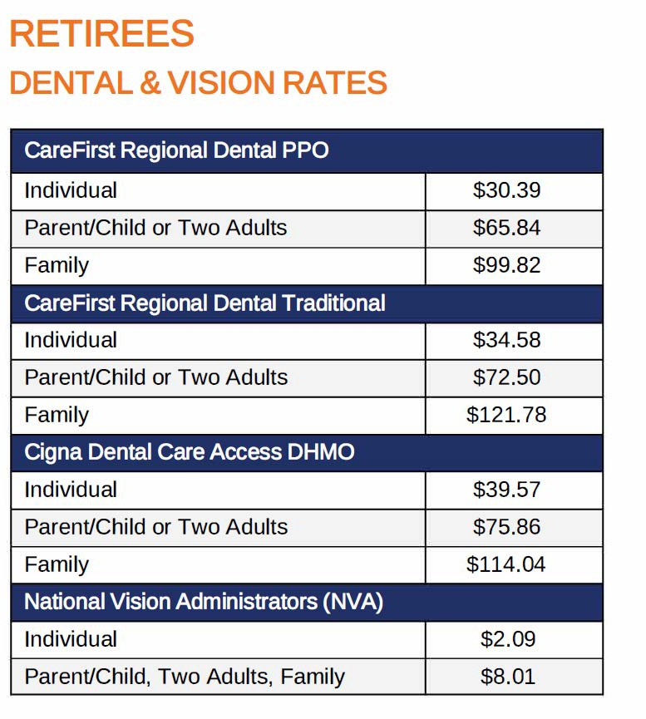

Enrollment
Life Insurance MetLife

A personalized life insurance election form will be provided to you by the Office of Benefits and Retirement. Continuation is optional. If you do not elect to continue this benefit at the time of retirement, you will forfeit your eligibility indefinitely. The life insurance election form must be completed and returned within thirty days of the effect date of your retirement. Please Note: Only the amount of coverage as an active employee can be continued into retirement. (No Exceptions)
(443) 290-3114 (TTY 711) or toll free (833) 550-1676 (TTY 711)
Benefit Amount & Reduction Schedule
Retirees may not elect to continue more than $50,000 in coverage. This includes $15,000 of Basic Term Life Insurance and up to $35,000 in Sup­ plemental Life Insurance.
Reduction Schedule
Supplemental Life Insurance coverage immediately reduces by 10% on the date of retirement. Therefore, the maximum amount of total Life Insurance on the date ofretirement is $46,500. Following retirement, the Supplemental Life Insurance will be reduced by the same dollar amount on each of the following four anniversaries of your retirement date. The cost of Life Insurance is paid entirely by the retiree. Premiums are deducted from your pension check. Coverage terminated for non-payment of premium cannot be reinstated.
See example below:

 | Date | Supplemental Coverage | Basic Coverage | Total Coverage
Active | June 1, 2024 | $65,000 | $15,000 | $80,000
Retired | July 1, 2024 | $31,500 | $15,000 | $46,500*
1st Year | July 1, 2025 | $28,000 | $15,000 | $43,000
2nd Year | July 1, 2026 | $24,500 | $15,000 | $39,500
3rd Year | July 1, 2027 | $21,000 | $15,000 | $36,000
4th Year | July 1, 2028 | $17,500 | $15,000 | $32,500

Cost of Coverage
Employees who retire at age 65 who elect to continue the Basic Term Life and the maximum amount of Supplemental Life Insurance will pay
$58.61 per month for $46,5000 in total benefit.

Monthly Cost for Basic Term Life Insurance
Retired Prior to 1/1/2005 $9.15 (for $7,380 of coverage)

Retired After 1/1/2005 $18.60 (for $15,000 of coverage)
Monthly Rate per $1,000 of Supplemental Life Insurance

Age | 50-54 | 55-59 | 60-64 | 65-69* | 70+
Rate | .23 | .43 | .66 | 1.27 | 2.06
Ages 25-49 contact the Office of Benefits, Leaves, and Retirement for rates

Rates can change based on the negotiations with Baltimore County Public Schools and Life insurance carriers.

Don't Forget to Designate a Beneficiary!
Choosing who will receive your Life Insurance benefit is an important decision. Please make sure your beneficiary is up to date.

Canceling Life Insurance
Retirees may cancel their Basic Term Life and/or Supplemental Life Insurance Coverage at any time. Coverage which has been canceled cannot be reinstated.

Cancer, Catastrophic, and Other Insurances
Cancer Insurance
Retirees who were enrolled in cancer insurance at the time of retirement could elect to continue to pay the premiums to keep the coverage. Premiums are deducted from pension checks in combination with the cost of health insurance. Thus, a retiree with cancer insurance will see a deduction from the pension check that combines the cost of both programs.

Retirees wishing to cancel this insurance must notify the Office of Benefits, Leaves, and Retirement for BCPS in writing. Coverage that is canceled cannot be reinstated.

This policy is through Washington National Insurance Co. (Conseco) (877) 372-5916.

Catastrophic Insurance
The insurance coverage has been billed by CareFirst BlueCross BlueShield for many years. Any billing or coverage questions should be addressed to CareFirst directly (410) 581-3404.

Accidental Death & Dismemberment (AD&D) Insurance
Retirees who were enrolled in AD&D at the time of retirement are able to continue the policy by contacting Prudential at (800) 778-3827 and con- verting the policy into an individual policy. Premiums will be paid directly to Prudential. Conversion must happen within thirty days immediately following retirement.

Plans Available Through MRSPA
Retiree dental, vision, and long-term care insurance plans are available to purchase through the Maryland Retired School Personnel Association.

Contact the MRSPA directly at (410) 551-1517 or online at www.mrspa.org for more details about eligibility guidelines and costs for these plans.

Plans Available Through TABCO Retired, an affiliate of TABCO, MSEA, and NEA
Retiree dental, vision, life, long-term care, and Medicare supplement are available with membership, through NEA benefits. Contact TABCO-Retired at 410-828-6403 or online at https://tabco.org/about- us/tabco-retired/.

IMPORTANT RESOURCES
Website: www.bcps.org
Email: cschelp@bcps.org

Benefits and Retirement Representatives are available to help answer your questions and address any concerns you have regarding your BCPS benefits. All benefits information and forms can be found and downloaded from our website.
- Updates to beneficiaries must be handled directly with the pension system and the life insurance companies.
- If you have an address, phone number or name change, we must receive the change in writing, and you must also notify the pension system.
- If you are calling to report a death, the pension system, Social Security and Medicare, and Life Insurance company (if applicable) must also be notified separately.

Coverage/Service Phone Number Website

Office of Retirement - BCPS
Maryland State Retirement Agency (SRA)

(443) 809-8949

(410) 625-5555
bcps.org sra.state.maryland.us

Baltimore County Employees Retirement System | (410) 887-2568 | baltimorecountymd.gov/departments/ benefits/
Medicare Help Line | (800) 633-4227 | Medicare.gov
Social Security Administration | (800) 772-1213 | ssa.gov
Non-Medicare Medical - Cigna | (800) 896-0948 | myCigna.com
Cigna Home Delivery Pharmacy | (800) 285-4812 | myCigna.com
Behavioral Health - Cigna | (800) 724-7603 | myCigna.com
Non-Medicare Medical - Kaiser Permanente | (800) 777-7902 | kp.org
Behavioral health - Kaiser Permanente | (800) 777-7904 | kp.org
Kaiser Permanente Medicare Advantage (HMO) | (888) 777-5536 | kp.org
Dental - CareFirst | (866) 891-2802 | member.CareFirst.com
Dental - Cigna | (800) 896-0948 | myCigna.com
Vision - National Vision Administrators (NVA) | (800) 672-7723 | e-nva.com
Cancer Insurance | (877) 372-5916 | my.washingtonnational.com
Life Insurance Claims & Beneficiaries - MetLife | (866) 492-6983 | metlife.com/mybenefits
Retiree Benefits Billing - VOYA/Benefit Strategies LLC | (888) 401-3539 | benstrat.com
Catastrophic Insurance - CareFirst | (410) 581-3404 | N/A

CANCER INSURANCE

This benefit is no longer offered to current employees or new hires after 7/1/2007.
If you are currently enrolled in cancer insurance at the time of your retirement, you may elect to continue to pay the premiums to keep the coverage into retirement. If you wish to cancel this insurance, you must notify the Office of Benefits and Retirement in writing. Coverage that is canceled cannot be reinstated.
This policy is through Washington National Insurance Co. (Conseco) (877) 372-5916.

CATASTROPHIC INSURANCE
The insurance coverage has been billed by CareFirst BlueCross BlueShield for many years. Any billing or coverage questions should be addressed to CareFirst directly (410) 581-3404.

BALTIMORE COUNTY RETIRED SCHOOL PERSONNEL ASSOCIATION (BCRSPA)
If you are looking for a way to stay informed about your benefits and the education community in Baltimore County and the State of Maryland, contact BCRSPA 443-793-5867 or online at www.bcrspa.org for details.

MARYLAND RETIRED SCHOOL PERSONNEL ASSOCIATION (MRSPA)
Retiree dental, vision, and long-term care insurance plans are available to purchase through the Maryland
Retired School Personnel Association. Contact the MRSPA directly at (410) 551-1517 or online at
www.mrspa.org for more details about eligibility guidelines and costs for these plans.

TABCO- RETIRED

Plans available through TABCO-Retired, an affiliate of TABCO. MSEA and NEA
Retiree dental, vision, life, long-term care, and Medicare supplement are available with membership, through NEA Benefits. Contact TABCO-Retired at (410) 828-6403 or online at
https://tabco.org/aboutus/tabco-retired/.

RETIREE FREQUENTLY ASKED QUESTIONS

I turn 65 soon, do I need to sign up for Medicare?
- If you want to continue your health insurance coverage under BCPS, you must enroll in Medicare parts A&B when you first become eligible. You do not need to enroll in Medicare part D because all Medicare plans offered through BCPS are bundled with prescription drug coverage. If you choose to cancel your health coverage through BCPS, we must receive notification in writing.

How do I change my name/address/phone number?
- Personal and/or demographic changes must be received in writing. We cannot update your information over the phone.

Can I take a loan against my retirement?
  - Hardship withdrawals and loans are only available to employees who are contributing to either a 403(b) or 457(b) supplemental retirement account. Loans may not be taken against your pension retirement account.
How do I get a new insurance ID card?
ID cards for medical, prescription, dental, and vision benefits must be requested from the insurance companies directly. Contact numbers can be found on page 19 of this guide. ID cards may also be requested, and temporary cards downloaded electronically by setting up a personal online account on the insurance company’s website.
How do I report the death of a spouse or dependent?
If the spouse or dependent of a retiree passes away and they had coverage under any of the BCPS benefit plans, please contact the Office of Benefits as soon as possible and forward a copy of the death certificate so they can be removed from coverage.
How do I report the death of the retiree?
If the retiree has coverage under any of the BCPS benefit plans, including life insurance, please contact the Office of Benefits as soon as possible and forward a copy of the death certificate so they can be removed from coverage. If the retiree had any life insurance, BCPS will forward a copy of the death certificate to Metlife to begin the claims process. If they retired prior to January 1, 2005, they may also have a paid-up MetLife life insurance policy. MetLife would have to be contacted directly (888) 280-6083.
The death of the retiree must be reported separately to Social Security Administration and their pension system, BCPS does not communicate with those entities.
Surviving Spouse Benefit: Upon a retiree’s death if they had a spouse or dependents covered under a BCPS health plan, the spouse and dependents have the option to continue coverage. For one year following the retiree’s death coverage may be continued and will include the contribution from the Board of Education. A surviving spouse may not add any dependents who were not previously covered.
Who is my beneficiary and how do I change my beneficiary?
Beneficiary information is not held by BCPS. If you are unsure who your beneficiaries are or you would like to change your current designation, you will need to contact the life insurance companies and the applicable pension system directly.

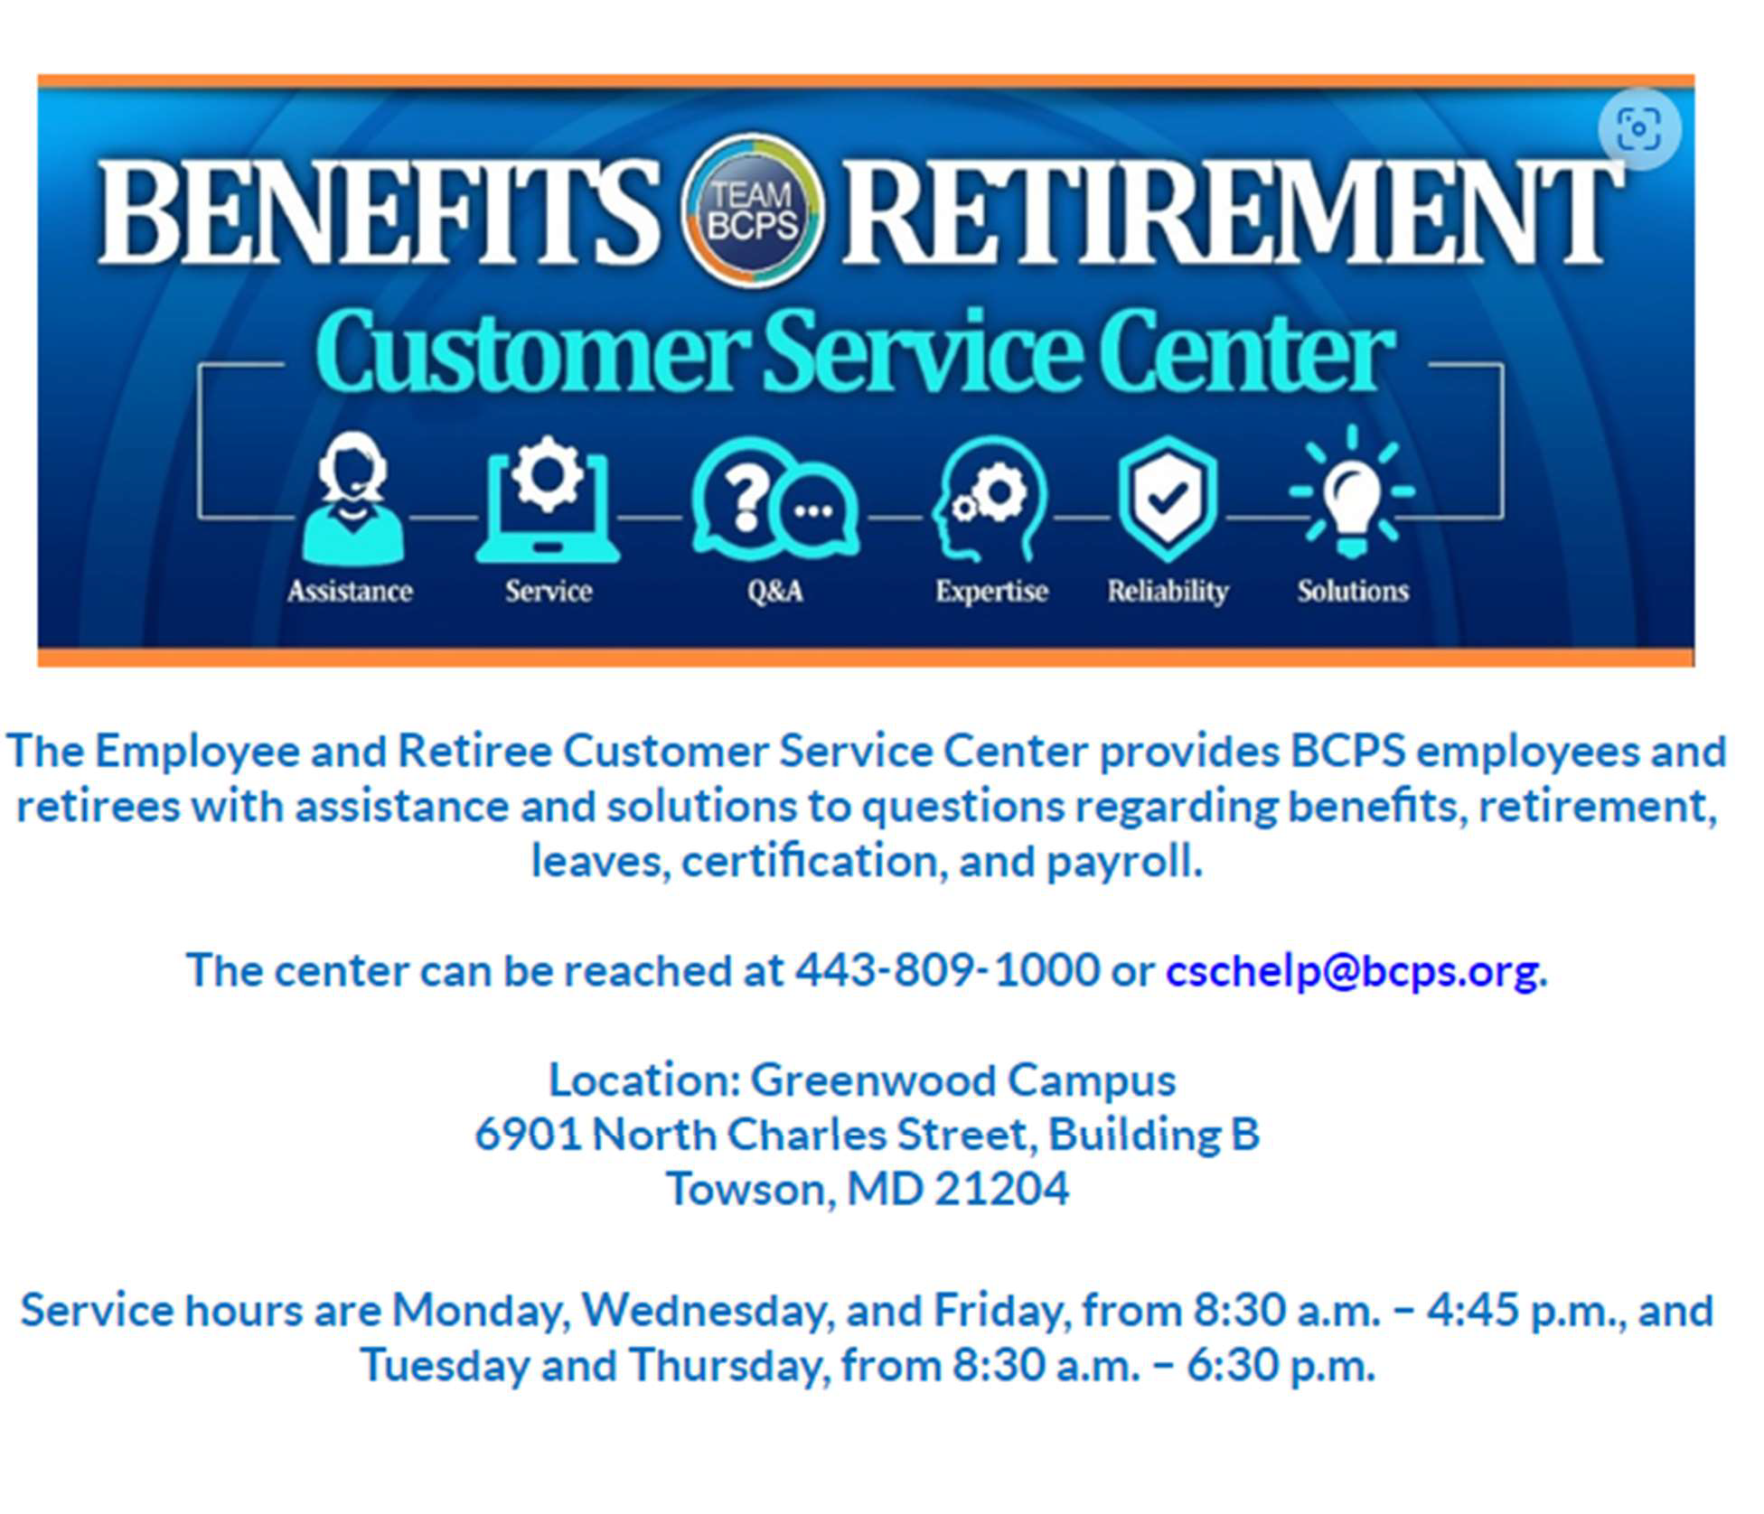

Making Changes
To make changes to your contributions or to stop deductions, you will need to complete another SRA and submit it to the Office of Benefits and Retirement.

PLANNING ON RETIRING?
Deciding whether to retire is an important decision which requires planning and careful consideration. Employees who are planning on retiring should review the pre-retirement checklist appropriate for their pension plan. These can be found on the website for the Office of Benefits and Retirement or you can request a copy.

Retiree Benefits
Retiree insurance benefits are provided by the Board of Education regardless of the plan from which you receive your pension. The insurance benefits and the Board’s contribution percentages are subject to change in the future depending upon the agreements reached by the Board, its bargaining units, and its funding authorities.
- Your share of the cost of benefits is based on your years of service, the insurance plans you choose, and the eligible dependents you enroll.
- For purposes of determining the Board’s share of the cost of benefits, only years of service to BCPS and military service up to five (5) years are credited. Time on unpaid leaves of absence or time worked in a temporary, substitute, or contractual capacity is not credited.

Eligibility and Enrollment
Retirees who, immediately following active employment, begin to receive a monthly pension are eligible to enroll themselves and their eligible dependents in medical/prescription, dental, and vision plans. Life Insurance plans may be continued if enrolled while employed. An enrollment/change form must be completed to enroll in benefits or make changes. Retirees who do not qualify for a pension or who have elected to defer pension benefits, regardless of vested status, are ineligible to participate in benefits.

RETIREE RESOURCES & OTHER COVERAGES

PLANNING ON RETIRING?

Medical - Non Medicare and Medicare
Retirees are not required to enroll in this benefit immediately upon retirement in order to preserve the right to enroll at a later date.
Retirees and their eligible dependents who are ineligible for Medicare will be offered the same medical/prescription plans as are offered to active employees.
Retirees and their eligible dependents upon becoming eligible for Medicare will be required to enroll in Medicare Parts A & B in order to newly enroll or continue enrollment in the Board’s plans. They will also be required to change their enrollment to one of the Board’s Medicare Supplement plans. Enrollment in a Medicare Supplement plan includes coverage for prescription drugs and is considered creditable coverage.

Dental and Vision
Retirees are not required to enroll in this benefit immediately upon retirement in order to preserve the right to enroll at a later date.
Retirees and their eligible dependents will be offered the same dental and vision plans as are offered to active employees.
The Board does not contribute to the cost of these benefits after an employee retires.

Life and Supplemental Life
- Retirees must elect to continue this benefit at the time of retirement. It may not be waived and then elected at a later date.
- Retirees may not elect to continue more than
$50,000 coverage. This includes $15,000 of Basic Term Life and up to $35,000 in Supplemental Life Insurance.
- Supplemental Life Insurance will be reduced
10% on the date of retirement and additionally by 10% on the anniversary of retirement for the following 4 years.
- The amount of coverage may never be
increased following retirement, only reduced.

Enrolling and Changing Benefits
Retirees will need to complete an enrollment/change form. Requests will be effective on the first of the month following receipt of request.

GLOSSARY
Out-of-Pocket Maximum—The most a member would have to pay for covered services in a plan year including copays, deductibles, and coinsurance. After you have spent this amount, the medical plan pays 100% of the costs of covered benefits. Cigna medical plans have a separate OOP maximum for prescription benefits. All BCPS medical plans have embedded OOP accruals meaning that when the employee has family coverage, one member of the family will pay no more than the individual amount.

Annual Benefit Maximum—The most the dental plan has to pay towards covered services in a plan year. After the annual benefit maximum has been exhausted, the dental plan will not contribute anything additional towards covered services. Cigna DHMO does not have an annual benefit maximum.

Allowed Amount—The contracted amount a participating provider is allowed to charge for a covered service.

Balance Billing—A non-participating provider may bill you for the difference between the allowed amount for covered services and their charge. For example, if the provider’s charge is
$100 and the allowed amount is $70, the provider may bill you for the remaining $30. Participating providers may not balance bill.

Formulary—A list of prescription drugs covered by a prescription plan that are preferred. These drugs can be generic or brand name. Formulary drugs are chosen for their cost, effectiveness, and safety and will typically have a lower cost to the member.

NOTES

31
(443) 290-3114 (TTY 711) or toll free (833) 550-1676 (TTY 711)

Important Contacts
32 (443) 290-3114 (TTY 711) or toll free (833) 550-1676 (TTY 711)

CONTACT | REGARDING
RetireeFirst, LLC  1000 Midlantic Drive, Suite 100 Mount Laurel, NJ 08054  Phone: (443) 290-3114 (TTY 711) or  (833) 550-1676 (TTY 711)  Email: baltimore@retireefirst.com Website: www.retireefirst.com | - Medical and Prescription billing questions  - Assist with enrollment  - Eligibility verification from providers  - Medical and Prescription prior authorizations  - Drug and co-pay lookup  - Provider and pharmacy network questions  - Medicare/SSA assistance and more
Baltimore County Public Schools Office of Benefits and Retirement  6901 N. Charles Street, Towson, MD 21204  Phone: (433) 809-8949  Fax: (410) 887-8950  Email: retirement@bcps.org  Website: hr.bcps.org/departments/human_resources_ operations/benefits_leaves_and_retirement/benefits/retiree_ benefits | - Who is eligible for County health plan coverage?  - Life status changes–i.e. marriage, divorce, birth, adoption, death of dependents, loss of dependent status  - Changes to life insurance beneficiaries  - Assistance with benefits elections when retiring  - Dental and Vision enrollments  - Questions about your pension benefits  - Questions about who you designated as your retirement beneficiary  - Requests for retirement conferences  - Changes to your address or other retirement  information on file  - Life status changes–i.e. marriage, divorce, or death of spouse/dependent or other retirement beneficiary
Kaiser Permanente Medicare Advantage Plan with Rx - HMO Option  Phone: (888) 777-5536 | - Plan benefit detail  - Claims questions  - Request ID card
Social Security Administration (SSA) Phone: (800) 772-1213  Website: www.ssa.gov | - Change of address  - General Medicare Part A or B eligibility or premiums
Medicare Help Line  Phone: 1-800-MEDICARE (633-4227)  Website: www.medicare.gov | - Request new ID card  - Ordering Medicare publications  - General Medicare information

