
2026 – Town of Wrentham group supplement to Medicare with Prescription Drug Plan

Your Dedicated Advocacy Phone Numbers

(508) 744-6804 (TTY 711) or toll free (833) 217-5312 (TTY 711)

Frequently Asked Questions

Plan Design
Medical Carrier:

Medical |  | You pay
Deductible |  | $0
Office Visit: Primary Care |  | $0
Office Visit: Specialist |  | $0
Inpatient Hospital |  | $0
Outpatient Care |  | $0
Home Health Care |  | $0
Skilled Nursing Facility |  | $0, days 21-100  $10, days 101-365
Emergency Room |  | $0
Urgent Care |  | $0
Lab Services |  | $0
Radiology Services |  | $0
Durable Medical Equipment |  | $0
Preventative Screenings |  | $0
Chiropractic |  | $0 Medicare covered services
Acupuncture |  | $0 Medicare covered services
Podiatry |  | $0 Medicare covered services

Prescription Carrier
Prescription | 30-day Retail  You pay up to |  | 90-day Retail  You pay up to | 90-day Mail Order  You pay up to
Annual Deductible: $0
Tier 1 Generic | $5 |  | $15 | $10
Tier 2 Preferred Brand | $10 |  | $30 | $20
Tier 3 Non-Preferred Brand | $25 |  | $75 | $50
Tier 4 Specialty | Specialty medications are included in tier 3,and are limited to a 30-day supply.

Plan Questions

- How do I enroll in this plan?
To finalize your enrollment into the plan, the enclosed applications need to be completed and returned to RetireeFirst in the included pre-paid envelope.

- Can I stay with the current plan?
No, all Medicare-eligible retirees and/or dependents must change over to this plan. Your current plan will no longer be available.

- When will I receive my ID card and welcome kit?
Cards and welcome kits should arrive in the month prior to your start date. Retirees and Medicare-eligible dependents will each receive their own card. Please note that each enrollee may not receive their plan information on the same day; this is normal.

- What do I do if I lose my card?
Please call RetireeFirst at (508) 744-6804 (TTY 711) or toll free (833) 217-5312 (TTY 711) and we will obtain a new one on your behalf, mail you a temporary card, and call your pharmacy and/or providers if needed.

- If I leave the plan, will it affect any of my other benefits?
Yes, it may.

- How much do I have to pay for the plan?
Town of Wrentham can be reached at (508) 384-5400 to answer any billing questions.

- Who do I call if I need assistance with the plan?
Please call RetireeFirst at (508) 744-6804 (TTY 711) or toll free (833) 217-5312 (TTY 711) to reach your dedicated Town of Wrentham Retiree Advocacy Team, Monday-Friday, 8am-5pm, EST.

Medical Questions

- Is there a medical deductible?
No, there is no medical deductible.

- Is there co-insurance or copays?
No, there is no co-insurance or copays.

- Does this plan require referrals?
No, this plan does not require referrals.

- Does this plan require pre-certifications?
No, this plan does not require pre-certifications.

- Does this plan have a network?
No, you can go to any willing Medicare provider, hospital, or facility.

- Can I go to my current providers?
Yes, you can see any provider that accepts Medicare.

- Do I still use my Medicare card?
Yes, you will use both your Medicare card and your BCBS of MA Medex ID Card at your provider’s office.

Prescription Questions

- Is there a prescription deductible?
No, there is no prescription deductible.

- Is there co-insurance or copays?
Yes, there are copays for your medications. Please see copay chart on page 2.

- Are my prescriptions covered?
Most likely yes, the prescription list is a comprehensive formulary just as before. Please call RetireeFirst at (508) 744-6804 (TTY 711) or toll free (833) 217-5312 (TTY 711) if you need help looking up your prescriptions.

- Can I go to the same retail pharmacy?
Most likely, yes. There should be little to no pharmacy disruption. Blue MedicareRX has over 65,000 pharmacies in network. You do NOT need new prescriptions for retail pharmacy refills. You will need to show both your Medicare and your new Blue MedicareRX prescription card.

- Is there a mail order pharmacy?
There is a mail order pharmacy called CVS Caremark Mail Service Pharmacy which can be reached at (877) 817-0493 (EST). You can also call your dedicated RetireeFirst Advocates at (508) 744-6804 (TTY 711) or toll free (833) 217-5312 (TTY 711) with questions about mail order prescriptions.

- Is there a specialty mail order pharmacy?
Blue MedicareRX has a specialty pharmacy called CVS Specialty which can be reached at (866) 846-3096 (EST). You can also call RetireeFirst at (508) 744-6804 (TTY 711) or toll free (833) 217-5312 (TTY 711) with questions about specialty prescriptions.

- Will my prescriptions transfer from the old plan?
If you use the retail pharmacy, and have refills remaining, you do NOT need to obtain new prescriptions. If you use mail order, you WILL need to obtain new prescriptions from your provider.

- Can I still go to the Veterans Affairs (VA) for my prescriptions?
Yes, if you obtain some prescriptions from the VA, you may continue to do so.

- Do I need prior authorizations for certain prescription medicines?
Some prescriptions may require a prior authorization. Please contact RetireeFirst at (508) 744-6804 (TTY 711) or toll free (833) 217-5312 (TTY 711) if you have questions or need assistance with prior authorizations as well as any other requirements such as step therapy, quantity limit, or formulary exceptions.

- What is the catastrophic phase and is there coverage?
The catastrophic phase is a phase of coverage designed to protect you from having to pay very high out-of-pocket costs for prescription drugs. It is the final phase in your prescription drug plan and your copays will be $0. You will remain in this phase for the rest of the plan year. This coverage phase kicks in when you reach a true out of pocket total of $2100 for prescription drugs.

- What is the annual maximum out-of-pocket (MOOP) and how does it work?
Once your out-of-pocket costs for prescription drugs reaches $2100, your copays will be $0. You will remain in this phase of coverage for the rest of the plan year.

Medex 2 Card Sample:

Front: Back:
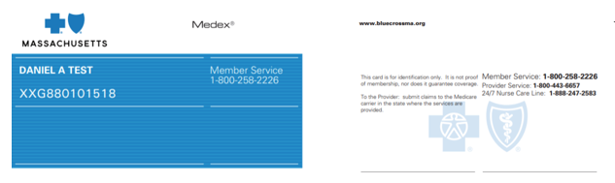

Blue Medicare RX Card Sample:

Front: Back:
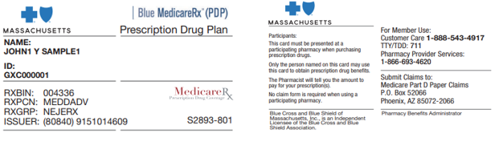
Disclaimer: For complete benefit details please refer to the carrier issued materials. This document includes a simplified summary of benefits and does not create any contractual rights.

