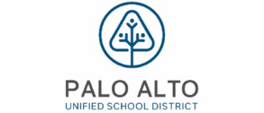
2026 – Palo Alto Unified School District group supplement to Medicare Plan

Your Dedicated Advocacy Phone Number
(650) 281-0137 (TTY 711) or toll free (833) 265-8649 (TTY 711)

Frequently Asked Questions

Plan Design
Medical Carrier:

Medical |  | You pay
Part A Deductible |  | $0
Part B Deductible |  | $0
Office Visit: Primary Care |  | $0
Office Visit: Specialist |  | $0
Inpatient Hospital |  | $0
Outpatient Care |  | $0
Home Health Care |  | $0
Skilled Nursing Facility |  | $0, days 1-100
Emergency Room |  | $0
Urgent Care |  | $0
Ambulance Service |  | $0
Lab Services |  | $0
Radiology Services |  | $0
Durable Medical Equipment |  | $0
Preventative Screenings |  | $0
Chiropractic |  | Medicare Covered Services Only
Acupuncture |  | Medicare Covered Services Only
Podiatry |  | Medicare Covered Services Only
Foreign Travel (World-wide) Coverage |  | $250 deductible, 20% coinsurance and  amounts over the $50,000 lifetime maximum for medically necessary emergency care services beginning during the first 60 days of each trip outside the USA
Hearing |  | Medicare Covered Services Only
Vision |  | Medicare Covered Services Only
Dental |  | Medicare Covered Services Only
Fitness Benefit |  | Medicare Covered Services Only

Plan Questions

- Will I be automatically enrolled in the new plan, or do I need to do anything to enroll?
All Medicare-eligible retirees and/or dependents will be automatically enrolled into the plan. There is nothing you need to do to be enrolled.

- Can I stay with the current plan?
No, all Medicare-eligible retirees and/or dependents must change over to this plan. Your current plan will no longer be available.
- Can I opt-out of this plan?
We are required by law to give you the choice of opting out of the new plan. Since you are enrolled in the current medical plan it is unlikely that you would not want to participate in this new plan. However, you have the option to opt-out and decline this medical coverage. Nevertheless, if you would like to opt-out, please call RetireeFirst at (650) 281-0137 (TTY 711) or toll free (833) 265-8649 (TTY 711), Monday-Friday, 8am-5pm PST.

- Are there any plan changes?
Palo Alto Unified School District did their best to match or enhance your current benefits. Below are a few highlights of your new plan:
  - You have a $0 Medical Deductible with this plan.
  - Medicare Covered Medical Services are $0 cost to you.
  - You pay $0 copay for Primary Care and Specialist visits.
  - You pay $0 copay for Emergency Room visits.
  - You pay $0 copay for Skilled Nursing Facility Care (Days 1-100).
  - You have Foreign Travel Coverage - $250 Deductible, 20% coinsurance and amounts over the $50,000 lifetime maximum for medically necessary emergency care services beginning during the first 60 days of each trip outside the USA.
  - Continued access to RetireeFirst Advocates for assistance with understanding and using your benefits.
- When will I receive my ID card and welcome kit?
Cards and welcome kits should arrive in the month prior to your start date. Retirees and Medicare-eligible dependents will each receive their own card. Please note that each enrollee may not receive their plan information on the same day; this is normal.

- What do I do if I lose my card?
Please call RetireeFirst at (650) 281-0137 (TTY 711) or toll free (833) 265-8649 (TTY 711) and we will obtain a new one on your behalf, mail you a temporary card, and call your pharmacy and/or providers if needed.

- If I leave the plan, will it affect any of my other benefits?
Yes, if you choose to opt out of this new plan or leave either the United American Retiree Health Plan or the ESI Prescription Drug Plan at a later date, you will have no Medical or Rx coverage through Palo Alto Unified School District. If you choose to leave one plan, you cannot keep the other. If you have any questions about this, please call RetireeFirst at (650) 281-0137 (TTY 711) or toll free (833) 265-8649 (TTY 711) Monday-Friday, 8am-5pm, PST.

- How much do I have to pay for the plan?
Your monthly rate can be found under “Rate Payment ACH Options” on the enclosed Announcement Letter. The rate will be automatically deducted from your bank account monthly via RetireeFirst ACH on the 3rd of the effective month of coverage (or the next business day). Please call RetireeFirst at (650) 281-0137 (TTY 711) or toll free (833) 265-8649 (TTY 711) if you have questions.

- Who do I call if I need assistance with the plan?
Please call RetireeFirst at (650) 281-0137 (TTY 711) or toll free (833) 265-8649 (TTY 711) to reach your dedicated Palo Alto Unified School District Retiree Advocacy Team, Monday-Friday, 8am-5pm, PST.

Medical Questions

- Is there a medical deductible?
No, there is no Part A or Part B deductible with this plan.

- Is there co-insurance or copays?
No, there is no co-insurance or copays for Medical services with this plan.

- Does this plan require referrals?
No, this plan does not require referrals.

- Does this plan require pre-certifications?
No, this plan does not require pre-certifications.

- Does this plan have a network?
No, you can go to any willing Medicare provider, hospital, or facility.

- Can I go to my current providers?
Yes, you can see any provider that accepts Medicare.

- Do I still use my Medicare card?
Yes, you will present both your Medicare card and your United American ID Card to medical providers.

United American Retiree Health Plan Card Sample:

Front: Back:
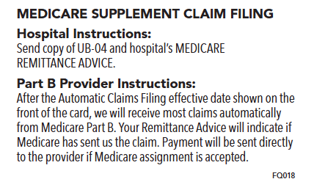
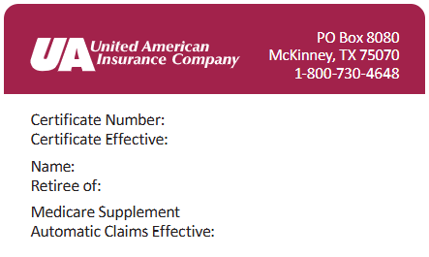

Disclaimer: For complete benefit details please refer to the carrier issued materials. This document includes a simplified summary of benefits and does not create any contractual rights. The policy under which this plan’s certificate is issued is not a standardized Medicare supplement plan.

