
2026 – Marble Local 7 Medicare Advantage and Prescription Drug Plans

Your Dedicated Advocacy Phone Number

718.215.5091(TTY 711)

Frequently Asked Questions

Plan Design
Medical Carrier:

Medical |  | You pay
Deductible |  | $0
Maximum Out of Pocket (MOOP) |  | $3400
Office Visit: Primary Care |  | $10
Office Visit: Specialist |  | $10
Inpatient Hospital |  | $0
Outpatient Care |  | $0
Home Health Care |  | $0
Skilled Nursing Facility |  | $0, Days 1-100
Emergency Room |  | $75, waived if admitted within 72 hours
Urgent Care |  | $10, waived if admitted within 72 hours
Ambulance Service |  | $50 per one way trip
Lab Services |  | $0
Radiology Services |  | $10
Durable Medical Equipment |  | $10
Preventative Screenings |  | $10
Chiropractic |  | Medicare Covered Services Only
Acupuncture |  | Medicare Covered Services Only
Podiatry |  | Medicare Covered Services Only
Foreign Travel (World-wide) Coverage |  | $75 Emergency Outpatient Care, waived if admitted within 72 hours.  $10 Urgently Needed Services, waived if admitted within 72 hours.  $0 Inpatient Care, 60 days per lifetime
Hearing |  | Medicare Covered Services Only
Vision |  | Medicare Covered Services Only
Dental |  | Medicare Covered Services Only
Fitness Benefit |  | SilverSneakers®

Prescription Carrier

Prescription | 30-day Retail  You pay up to |  | 90-day Retail  You pay up to | 90-day Mail Order  You pay up to
Annual Deductible: $0
Tier 1 Generic | $5 |  | $5 | $5
Tier 2 Brand | $8 |  | $8 | $8
Tier 3 Non-Preferred Brand | $10 |  | $10 | $10
Tier 4 Specialty | $20 |  | N/A | N/A
Insulin Medications | $35 |  | $105 | $105

Plan Questions

- How do I enroll in this plan?
To finalize your enrollment into the plan, the enclosed application, authorized representative form, need to be completed and returned to RetireeFirst in the included pre-paid envelope.

- Can I stay with the current plan?
No, all Medicare-eligible retirees and/or dependents must change over to this plan. Your current plan will no longer be available.

- When will I receive my ID card and welcome kit?
Cards and welcome kits should arrive in the month prior to your start date. Retirees and Medicare-eligible dependents will each receive their own card. Please note that each enrollee may not receive their plan information on the same day; this is normal.

- What do I do if I lose my card?
Please call RetireeFirst at 718.215.5091(TTY 711) and we will obtain a new one on your behalf, mail you a temporary card, and call your pharmacy and/or providers if needed.

- If I leave the plan, will it affect any of my other benefits?
Yes, it may. Please contact the Fund at 212.505.5050

- How much do I have to pay for the plan?
Marble Local 7 can be reached at 212.505.5050 to answer any billing questions.

- Who do I call if I need assistance with the plan?
Please call RetireeFirst at 718.215.5091(TTY 711) to reach your dedicated Marble Local 7 Retiree Advocacy Team, Monday-Friday, 8am-5pm, EST.

Medical Questions

- Is there a medical deductible?
No, the plan does not have a deductible, it does have a Medical Out-of-Pocket maximum of $3400.

- Is there co-insurance or copays?
Yes, the plan has copays. Please see the plan design above.

- Does this plan require referrals?
No, this plan does not require referrals.

- Does this plan require pre-certifications?
Some services may require pre-certification.

- Does this plan have a network?
Yes, but you can go to any willing Medicare provider, hospital, or facility. This plan’s in and out of network benefits are the same.

- Can I go to my current providers?
Yes, you can see any provider that accepts Medicare and is willing to bill Anthem.

- Do I still use my Medicare card?
No, put your Medicare card in a safe place in case you need it later. You will only use your Anthem ID Card for medical and prescriptions.

- What if my provider says they do not accept this plan?
If your provider accepts Medicare, the portion you are responsible for will remain the same whether they are considered in or out of network. You can go to any willing Medicare provider, hospital, or facility. Please call RetireeFirst at 718.215.5091(TTY 711) to assist; we can reach out to your provider to explain.

Prescription Questions

- Is there a prescription deductible?
No, there is no prescription deductible.

- Is there co-insurance or copays?
Yes, the prescription benefit does have copays.

- Are my prescriptions covered?
Most likely yes, the prescription list is a comprehensive formulary just as before. Please call RetireeFirst at 718.215.5091(TTY 711) if you need help looking up your prescriptions.

- Can I go to the same retail pharmacy?
Most likely, yes. There should be little to no pharmacy disruption. Humana has over 67,000 pharmacies in network. You do NOT need new prescriptions for retail pharmacy refills.

- Is there a mail order pharmacy?
There is a mail order pharmacy called CenterWell Mail Order which can be reached at (800) 379-0092. You can also call RetireeFirst at 718.215.5091(TTY 711) with questions about mail order prescriptions.

- Will my prescriptions transfer from the old plan?
If you use the retail pharmacy, and have refills remaining, you do NOT need to obtain new prescriptions. If you use mail order, you WILL need to obtain new prescriptions from your provider.

- Can I still go to the Veterans Affairs (VA) for my prescriptions?
Yes, if you obtain some prescriptions from the VA, you may continue to do so.

- Do I need prior authorizations for certain prescription medicines?
Some prescriptions may require prior authorization. Please contact RetireeFirst at 718.215.5091(TTY 711) if you have questions or need assistance with prior authorizations as well as any other requirements such as step therapy, quantity limit, or formulary exceptions.

- What is the catastrophic phase and is there coverage?
The catastrophic phase is a phase of coverage designed to protect you from having to pay very high out-of-pocket costs for prescription drugs. It is the final phase in your prescription drug plan and your copays will be $0. You will remain in this phase for the rest of the plan year. This coverage phase kicks in when you reach a true out of pocket total of $2,100 for prescription drugs. Keep in mind, lifestyle and non-part D prescription drugs do not count toward your out-of-pocket total.

- What is the annual maximum out-of-pocket (MOOP) and how does it work?
Once your out-of-pocket costs for prescription drugs reaches $2,100, your copays will be $0. You will remain in this phase of coverage for the rest of the plan year. Keep in mind, lifestyle and non-part D prescription drugs do not count toward your out-of-pocket total

Anthem Preferred Medicare (PPO) Card Sample:

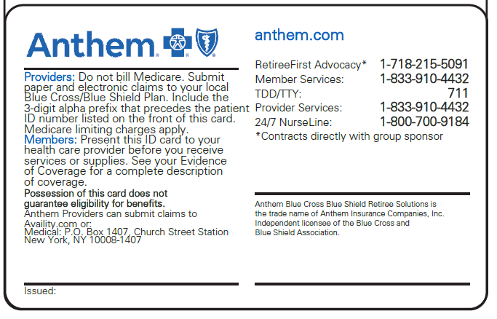
Front: Back:
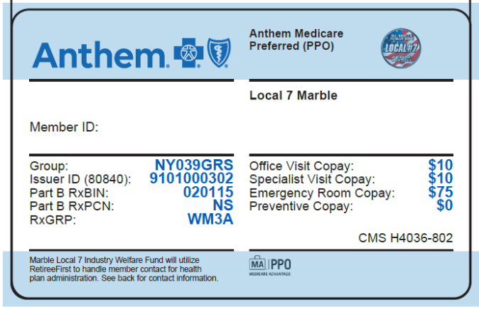

Humana Group Medicare Prescription Drug (PDP) Plan Card Sample:

Front: Back:
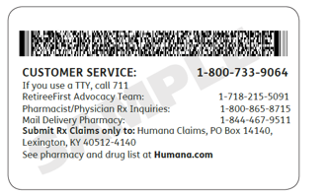
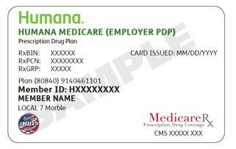

Disclaimer: For complete benefit details please refer to the carrier issued materials. This document includes a simplified summary of benefits and does not create any contractual rights.

