
2026 – IBEW Local 25 Health & Benefit Medicare Advantage with Prescription Drug Plan (MAPD)

Your Dedicated Advocacy Phone Numbers

(631) 301-4347 (TTY 711) or toll free (855) 460-7493(TTY 711)

Frequently Asked Questions

Plan Design
Medical Carrier:

Medical |  | You pay
Deductible |  | $0
Maximum Out of Pocket (MOOP) |  | $400
Office Visit: Primary Care |  | 20%
Office Visit: Specialist |  | 20%
Inpatient Hospital |  | $200 copay per day, 1-5 days per admission
Outpatient Care |  | 20%
Home Health Care |  | 20%
Skilled Nursing Facility |  | $0 copay per day (1-20 days per benefit period), 20% coinsurance (21-00 days per benefit periods
Emergency Room |  | $120 copay per visit (Waived if admitted within 72 hours)
Urgent Care |  | $50 copay per visit (Waived if admitted within 72 hours)
Ambulance Service |  | 20%
Lab Services |  | 20%
Radiology Services |  | 20%
Durable Medical Equipment |  | 20%
Preventative Screenings |  | $0
Podiatry |  | 20%, 12 visits per year
Foreign Travel (World-wide) Coverage |  | $120 copay, Emergency Room- waived if admitted within 72 hrs.  $50 copay, Urgently Needed Care- waived if admitted with 72 hrs.  $200 Copay for Inpatient Care- 60 Days Lifetime Max  Does not apply to Max Out of Pocket
Hearing |  | $0 copay, Routine Hearing Exam – 1 per year $70 Max benefit  $0 copay, Fitting & Evaluations – 1 per hearing aid $70 Max benefit.  $70 combined between Exam and Evaluations  $1,000 Allowance – Every year – Supplied by Hearing Care Solutions, 866-344-7756  Does not apply to Max Out of Pocket
Vision |  | $0 copay, Routine Eye Exam – 1 per year $70 Max benefit  $100 Allowance – every 2 years
Dental |  | Medicare Covered Services Only
Fitness Benefit |  | SilverSneakers®

Prescription Carrier
Prescription | 30-day Retail  You pay up to | 90-day Retail  You pay up to | 90-day Mail Order  You pay up to
Annual Deductible: $0
Tier 1 Generic | $0 | $0 | $0
Tier 2 Preferred Brand | 20% | 20% | 20%
Tier 3 Non-Preferred Brand | 20% | 20% | 20%
Tier 4 Specialty | $ | N/A | N/A

Plan Questions

- How do I enroll in this plan?
All Medicare-eligible retirees and/or dependents will be automatically enrolled into the plan. There is nothing you need to do to be enrolled.

We are required by law to give you the choice of opting out of the new plan. Since you are enrolled in the current medical and prescription drug plan it is unlikely that you would not want to participate in this new robust plan. However, you have the option to opt-out and decline this coverage. Nevertheless, if you would like to opt-out, please call RetireeFirst at (631) 301-4347(TTY 711) or toll free (855) 460-7493(TTY 711) Monday-Friday, 8am-5pm EST.

- Can I stay with the current plan?
No, all Medicare-eligible retirees and/or dependents must change over to this plan. Your current plan will no longer be available.

- When will I receive my ID card and welcome kit?
Cards and welcome kits should arrive in the month prior to your start date. Retirees and Medicare-eligible dependents will each receive their own card. Please note that each enrollee may not receive their plan information on the same day; this is normal.

- What do I do if I lose my card?
Please call RetireeFirst at (631) 301-4347(TTY 711) or toll free (855) 460-7493(TTY 711) and we will obtain a new one on your behalf, mail you a temporary card, and call your pharmacy and/or providers if needed.

- If I leave the plan, will it affect any of my other benefits?
Yes, it may. If you choose to leave the IBEW Local 25 Health & Benefit Fund plan you will not be able to re-enroll into the IBEW Local 25 Health & Benefit Fund plan later. Please call RetireeFirst at 631.301.4347 (TTY 711) or toll free 855.460.7493 (TTY 711) to discuss further

- How much do I have to pay for the plan?
IBEW Local 25 Health & Benefit Fund can be reached at 631.434.3344 to answer any billing questions.

- Who do I call if I need assistance with the plan?
Please call RetireeFirst at (631) 301-4347(TTY 711) or toll free (855) 460-7493(TTY 711) to reach your dedicated IBEW Local 25 Health & Benefit Fund Retiree Advocacy Team, Monday-Friday, 8am-5pm, EST.

Medical Questions

- Is there a medical deductible?
No, there is no medical deductible, but you will have a Medical Out of Pocket Maximum of $400 Annually.

- Is there co-insurance or copays?
Yes, the plan has co-insurance and copays.

- Does this plan require referrals?
No, this plan does not require referrals.

- Does this plan require pre-certifications?
Some services may require pre-certifications.

- Does this plan have a network?
Yes, but you can go to any willing Medicare provider, hospital, or facility. This plan’s in and out of network benefits are the same.

- Can I go to my current providers?
Yes, you can see any provider that accepts Medicare and is willing to bill Anthem.

- Do I still use my Medicare card?
No, put your Medicare card in a safe place in case you need it later. You will only use your Anthem ID Card for medical and prescriptions.

- What if my provider says they do not accept this plan?
If your provider accepts Medicare, the portion you are responsible for will remain the same whether they are considered in or out of network. You can go to any willing Medicare provider, hospital, or facility. Please call RetireeFirst at (631) 301-4347(TTY 711) or toll free (855) 460-7493(TTY 711) to assist; we can reach out to your provider to explain.

Prescription Questions

- Is there a prescription deductible?
No, there is no prescription deductible.

- Is there co-insurance or copays?
Yes, the plan has co-insurance or copays.

- Are my prescriptions covered?
Most likely yes, the prescription list is a comprehensive formulary just as before. Please call RetireeFirst at (631) 301-4347(TTY 711) or toll free (855) 460-7493(TTY 711) if you need help looking up your prescriptions.

- Can I go to the same retail pharmacy?
Most likely, yes. There should be little to no pharmacy disruption. Anthem has over 66,000 pharmacies in network. You do NOT need new prescriptions for retail pharmacy refills.

- Is there a mail order pharmacy?
There is a mail order pharmacy called CarelonRX which can be reached at (833) 409-1228. You can also call RetireeFirst at (631) 301-4347(TTY 711) or toll free (855) 460-7493(TTY 711) with questions about mail order prescriptions.

- Is there a specialty mail order pharmacy?
Anthem has a specialty pharmacy called CarelonRX Specialty which can be reached at (833) 255-0647. You can also call RetireeFirst at (631) 301-4347(TTY 711) or toll free (855) 460-7493(TTY 711) with questions about specialty prescriptions.
- Will my prescriptions transfer from the old plan?
If you use the retail pharmacy, and have refills remaining, you do NOT need to obtain new prescriptions. If you use mail order, you WILL need to obtain new prescriptions from your provider.

- Can I still go to the Veterans Affairs (VA) for my prescriptions?
Yes, if you obtain some prescriptions from the VA, you may continue to do so.

- Do I need prior authorizations for certain prescription medicines?
Some prescriptions may require a prior authorization. Please contact RetireeFirst at (631) 301-4347(TTY 711) or toll free (855) 460-7493(TTY 711) if you have questions or need assistance with prior authorizations as well as any other requirements such as step therapy, quantity limit, or formulary exceptions.

- What is the catastrophic phase and is there coverage?
The catastrophic phase is a phase of coverage designed to protect you from having to pay very high out-of-pocket costs for prescription drugs. It is the final phase in your prescription drug plan and your copays will be $0. You will remain in this phase for the rest of the plan year. This coverage phase kicks in when you reach a true out of pocket total of $2100 for prescription drugs. Keep in mind, lifestyle and non-part D prescription drugs do not count toward your out-of-pocket total.

Anthem Blue Cross Blue Shield (PPO) with Senior RX Plus (MAPD) Card Sample:

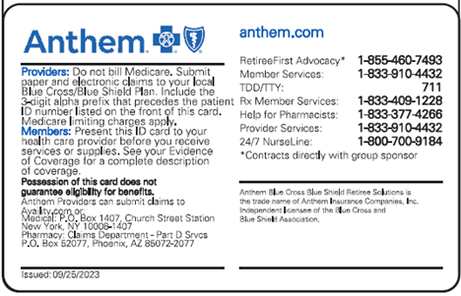
Front: Back:
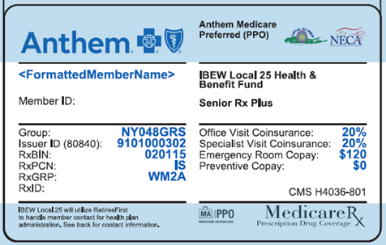

Disclaimer: For complete benefit details please refer to the carrier issued materials. This document includes a simplified summary of benefits and does not create any contractual rights.

