
2026 – NASI Welfare Fund Medicare Advantage and Prescription Drug Plans

Your Dedicated Toll-Free Advocacy Phone Number

(855) 433-1675(TTY 711)

Frequently Asked Questions

Plan Design
Medical Carrier:

Medical |  | You pay
Deductible |  | $0
Office Visit: Primary Care |  | $0
Office Visit: Specialist |  | $0
Inpatient Hospital |  | $0 Per admission
Outpatient Care |  | $0
Home Health Care |  | $0
Skilled Nursing Facility |  | $0
Emergency Room |  | $0
Urgent Care |  | $0
Ambulance Service |  | $0
Lab Services |  | $0
Radiology Services |  | $0
Durable Medical Equipment |  | $0
Preventative Screenings |  | $0
Chiropractic |  | $0, 26 visits per year
Foreign Travel (World-wide) Coverage |  | $0 Emergency and Urgent Care services
Hearing |  | Routine Hearing Exam - $0, every 12 months  Hearing Aid Allowance - $1,200 every 36 months
Vision |  | $0, Routine exam refraction every 12 months
Fitness Benefit |  | Included

Prescription Carrier

Prescription |  | 30-day Retail  You pay up to | 90-day Retail  You pay up to |  | 90-day Mail Order  You pay up to
Annual Deductible: $0
Tier 1 Generic |  | 15% Preferred / 20% Standard | 15% Preferred / 20% Standard |  | 15% Preferred / 20% Standard
Tier 2 Preferred Brand |  | 20% | 20% |  | 20%
Tier 3 Non-Preferred Brand |  | 30% | 30% |  | 30%
Tier 4 Specialty |  | 20% | N/A |  | N/A

Plan Questions

- How do I enroll in this plan?
Please contact RetireeFirst toll free (855) 433-1675(TTY 711 to provide your Medicare Beneficiary ID (MBI) Number so we can complete your Aetna® enrollment.

- Can I stay with the current plan?
No, all Medicare-eligible retirees and/or dependents must change over to this plan. Your current plan will no longer be available.

- When will I receive my ID card and welcome kit?
Cards and welcome kits should arrive in the month prior to your start date. Retirees and Medicare-eligible dependents will each receive their own card. Please note that each enrollee may not receive their plan information on the same day; this is normal.

- What do I do if I lose my card?
Please call RetireeFirst toll free (855) 433-1675(TTY 711) and we will obtain a new one on your behalf, mail you a temporary card, and call your pharmacy and/or providers if needed.

- If I leave the plan, will it affect any of my other benefits?
If you leave the plan, you can keep your dental and vision plans through NASI Welfare Fund; however, your premium for coverage will not be reduced.

- Who do I call if I need assistance with the plan?
Please call RetireeFirst toll free (855) 433-1675(TTY 711 to reach your dedicated National Automatic Sprinkler Industry (NASI) Welfare Fund Retiree Advocacy Team, Monday-Friday, 8am-5pm, EST.

Medical Questions

- Is there a medical deductible?
No, there is no medical deductible.

- Is there co-insurance or copays?
No, there is no co-insurance or copays.

- Does this plan require referrals?
No, this plan does not require referrals.

- Does this plan require pre-certifications?
Some services may require pre-certifications.

- Does this plan have a network?
Yes, but you can go to any willing Medicare provider, hospital, or facility. This plan’s in and out of network benefits are the same.

- Can I go to my current providers?
Yes, you can see any provider that accepts Medicare and is willing to bill Aetna.

- Do I still use my Medicare card?
No, put your Medicare card in a safe place in case you need it later. You will only use your Aetna ID Cards for medical and prescriptions.

- What if my provider says they do not accept this plan?
If your provider accepts Medicare, the portion you are responsible for will remain the same whether they are considered in or out of network. You can go to any willing Medicare provider, hospital, or facility. Please call RetireeFirst toll free (855) 433-1675(TTY 711 to assist; we can reach out to your provider to explain.

Prescription Questions

- Is there a prescription deductible?
No, there is no prescription deductible.

- Is there co-insurance or copays?
Yes, there is a cost share associated with this plan for prescriptions drugs.
Please refer to the prescription benefit chart above to better understand the prescription co-insurance.

- Are my prescriptions covered?
Most likely yes, the prescription list is a comprehensive formulary just as before. Please call RetireeFirst toll free (855) 433-1675(TTY 711 if you need help looking up your prescriptions.

- Can I go to the same retail pharmacy?
Most likely, yes. There should be little to no pharmacy disruption. Aetna has over 66,000 pharmacies in network. You do NOT need new prescriptions for retail pharmacy refills.

- Is there a mail order pharmacy?
There is a mail order pharmacy called CVS Caremark which can be reached at (888) 792-3862 (TTY 711). You can also call RetireeFirst toll free (855) 433-1675(TTY 711 with questions about mail order prescriptions.

- Will my prescriptions transfer from the old plan?
If you use the retail pharmacy, and have refills remaining, you do NOT need to obtain new prescriptions. If you use mail order, you WILL need to obtain new prescriptions from your provider.

- Can I still go to the Veterans Affairs (VA) for my prescriptions?
Yes, if you obtain some prescriptions from the VA, you may continue to do so.

- Do I need prior authorizations for certain prescription medicines?
Some prescriptions may require a prior authorization. Please contact RetireeFirst toll free (855) 433-1675(TTY 711 if you have questions or need assistance with prior authorizations as well as any other requirements such as step therapy, quantity limit, or formulary exceptions.

- What is the catastrophic phase and is there coverage?
The catastrophic phase is a phase of coverage designed to protect you from having to pay very high out-of-pocket costs for prescription drugs. It is the final phase in your prescription drug plan and your copays will be $0. You will remain in this phase for the rest of the plan year. This coverage phase kicks in when you reach a true out of pocket total of $2100 for prescription drugs. Keep in mind, lifestyle and non-part D prescription drugs do not count toward your out-of-pocket total.

- What is the annual maximum out-of-pocket (MOOP) and how does it work?
Once your out-of-pocket costs for prescription drugs reaches $2100, your copays will be $0. You will remain in this phase of coverage for the rest of the plan year. Keep in mind, lifestyle and non-part D prescription drugs do not count toward your out-of-pocket total.

Aetna Medicare Advantage (MA) Plan Card Sample:

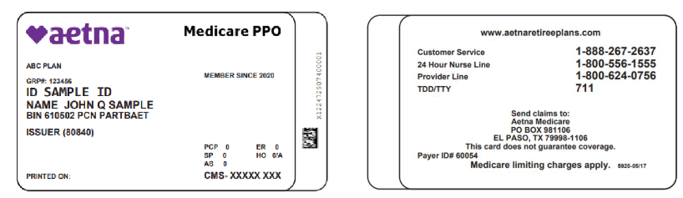
Front: Back:

Aetna Medicare Rx offered by SilverScript Card Sample:
Front: Back:
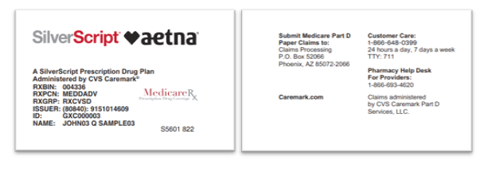

Disclaimer: For complete benefit details please refer to the carrier issued materials. This document includes a simplified summary of benefits and does not create any contractual rights.

