

2026 – City of Richardson Medicare Advantage PPO with Prescription Plan (MAPD)

Your Dedicated Advocacy Phone Numbers

(972) 200-1840 (TTY 711) or toll free (855) 460-7036 (TTY 711)

Frequently Asked Questions

Plan Design
Medical Carrier:

Medical |  | You pay
Deductible |  | $0
Office Visit: Primary Care |  | $0
Office Visit: Specialist |  | $0
Inpatient Hospital |  | $0 per admit
Outpatient Care |  | $0
Home Health Care |  | $0
Skilled Nursing Facility |  | $0, Days 1-100
Emergency Room |  | $0
Urgent Care |  | $0
Ambulance Service |  | $0
Lab Services |  | $0
Radiology Services |  | $0
Durable Medical Equipment |  | $0
Preventative Screenings |  | $0
Chiropractic |  | Medicare covered services only
Acupuncture |  | Medicare covered services only
Podiatry |  | $0, up to 6 visits per year
Foreign Travel (World-wide) Coverage |  | $0 at Urgent Care or Emergency Room  Limited to emergency Medicare-covered services
Hearing |  | $0 Routine Hearing Exam - 1 every year  $500 Hearing Aid Allowance - up to 2 every 3 years through TruHearing only.  Includes 80 batteries per aid and 3-year warranty
Vision |  | $0 Routine Eye Exam - 1 every 12 months  $100 eyewear allowance per year through Eye Med only
Dental |  | $1,000 combined maximum benefit  $0 comprehensive oral evaluation or periodontal exam up to 1 every 3 years  $0 panoramic film or diagnostic x-rays up to 1 every 5 years.  $0 bitewing x-rays up to 1 set(s) per year.  $0 emergency diagnostic exam, intraoral x-rays up to 1 per year.  $0 general anesthesia (nitrous oxide, anxiolysis, intravenous-conscious- sedation/analgesia)  20% amalgam and/or composite filling, emergency treatment for pain up to 2 per year.  20% simple or surgical extraction up to unlimited per year.  20% scaling and root planing (deep cleaning) up to 1 per quadrant every 3 years.  20% occlusal adjustment, scaling for moderate inflammation up to 1 every 3 years.  $0 fluoride treatment, periodic oral exam, prophylaxis (cleaning) up to 2 per year.  $0 periodontal maintenance up to 4 per year.  20% complete dentures, partial dentures up to 1 set(s) every 5 years.  20% adjustments to dentures, denture rebase, denture reline, denture repair, root canal or retreatment, tissue conditioning up to 1 per year.  20% coinsurance for other restorative services - core buildup and prefabricated post and core up to 1 per tooth per lifetime.
Fitness Benefit |  | SilverSneakers

Prescription Carrier
Prescription |  | 30-day Retail  You pay up to | 90-day Retail  You pay up to |  |  | 90-day Mail Order  You pay up to
Annual Deductible: $0
Tier 1 Generic |  | $15 | $45 |  |  | $30
Tier 2 Preferred Brand |  | $47 | $141 |  |  | $84
Tier 3 Non-Preferred Brand |  | $100 | $300 |  |  | $200
Tier 4 Specialty |  | 33% | N/A |  |  | N/A
Note: CMS caps the 30-day supply cost for Insulin medication at $35.
Costs for a 30-day supply may be less but will not exceed $35 for 2026.

Plan Questions

- How do I enroll in this plan?
To finalize your enrollment into the plan, the enclosed application, authorized representative form and ACH form need to be completed and returned to RetireeFirst in the included pre-paid envelope.

- Can I stay with the current plan?
No, all Medicare-eligible retirees and/or dependents must change over to this plan. Your current plan will no longer be available.

- When will I receive my ID card and welcome kit?
Cards and welcome kits should arrive in the month prior to your start date. Retirees and Medicare-eligible dependents will each receive their own card. Please note that each enrollee may not receive their plan information on the same day; this is normal.

- What do I do if I lose my card?
Please call RetireeFirst at (972) 200-1840 (TTY 711) or toll free (855) 460-7036 (TTY 711) and we will obtain a new one on your behalf, mail you a temporary card, and call your pharmacy and/or providers if needed.

- If I leave the plan, will it affect any of my other benefits?
Yes, it may. You are free to contact the City of Richardson’s Human Resources Department at (972) 744-4005 for more details.

- How much do I have to pay for the plan?
See table below. City of Richardson can be reached at (972) 744-4005 to answer any billing amount questions.
2026 Monthly Premium Rates (Effective 1/1/2026)
RETIREES WITH 20 YEARS OF SERVICE | City Pays | You Pay
Retiree | $200.00 | $156.92
Retiree and Spouse | $200.00 | $513.84
RETIREES WITH LESS THAN 20 YEARS OF SERVICE | City Pays | You Pay
Retiree | $0 | $356.92
Retiree and Spouse | $0 | $713.84

- Who do I call if I need assistance with the plan?
Please call RetireeFirst at (972) 200-1840 (TTY 711) or toll free (855) 460-7036 (TTY 711) to reach your dedicated City of Richardson Retiree Advocacy Team, Monday-Friday, 8am-5pm, CST.

Medical Questions

- Is there a medical deductible?
No, there is no medical deductible.

- Are there co-insurance or copays?
No, there are no co-insurance or copays.

- Does this plan require referrals?
No, this plan does not require referrals.

- Does this plan require pre-certifications?
Some services may require pre-certifications.

- Does this plan have a network?
Yes, but you can go to any willing Medicare provider, hospital, or facility. This plan’s in and out of network benefits are the same.

- Can I go to my current providers?
Yes, you can see any provider that accepts Medicare and is willing to bill Humana.

- Do I still use my Medicare card?
No, put your Medicare card in a safe place in case you need it later. You will only use your Humana ID Card for medical and prescriptions.

- What if my provider says they do not accept this plan?
If your provider accepts Medicare, the portion you are responsible for will remain the same whether they are considered in or out of network. You can go to any willing Medicare provider, hospital, or facility. Please call RetireeFirst at (972) 200-1840 (TTY 711) or toll free (855) 460-7036 (TTY 711to assist; we can reach out to your provider to explain.

Prescription Questions

- Is there a prescription deductible?
No, there is no prescription deductible.

- Are there co-insurance or copays?
Yes, there is a cost share associated with this plan for prescriptions drugs. Please refer to the prescription benefit chart on page 4 of this document to better understand the prescription co-pays and coinsurance

- Are my prescriptions covered?
Most likely yes, the prescription list is a comprehensive formulary just as before. Please call RetireeFirst at (972) 200-1840 (TTY 711) or toll free (855) 460-7036 (TTY 711), if you need help looking up your prescriptions.

- Can I go to the same retail pharmacy?
Most likely, yes. There should be little to no pharmacy disruption. Humana has over 63,000 pharmacies in network. You do NOT need new prescriptions for retail pharmacy refills.

- Is there a mail order pharmacy?
There is a mail order pharmacy called CenterWell Pharmacy which can be reached at (800) 379-0092 EST. You can also call RetireeFirst at (972) 200-1840 (TTY 711) or toll free (855) 460-7036 (TTY 711), with questions about mail order prescriptions.

- Is there a specialty mail order pharmacy?
Humana has a specialty pharmacy called CenterWell Specialty Pharmacy which can be reached at (800) 486-2668 EST. You can also call RetireeFirst at (972) 200-1840 (TTY 711) or toll free (855) 460-7036 (TTY 711), with questions about specialty prescriptions.
- Will my prescriptions transfer from the old plan?
If you use the retail pharmacy, and have refills remaining, you do NOT need to obtain new prescriptions. If you use mail order, you WILL need to obtain new prescriptions from your provider.

- Can I still go to the Veterans Affairs (VA) for my prescriptions?
Yes, if you obtain some prescriptions from the VA, you may continue to do so.

- Do I need prior authorizations for certain prescription medicines?
Some prescriptions may require a prior authorization. Please contact RetireeFirst at (972) 200-1840 (TTY 711) or toll free (855) 460-7036 (TTY 711), if you have questions or need assistance with prior authorizations as well as any other requirements such as step therapy, quantity limit, or formulary exceptions.

- What is the catastrophic phase and is there coverage?
The catastrophic phase is a phase of coverage designed to protect you from having to pay very high out-of-pocket costs for prescription drugs. It is the final phase in your prescription drug plan and your copays will be $0. You will remain in this phase for the rest of the plan year. This coverage phase kicks in when you reach a true out of pocket total of $2100 for prescription drugs. Keep in mind, lifestyle and non-part D prescription drugs do not count toward your out-of-pocket total.

- What is the annual maximum out-of-pocket (MOOP) and how does it work?
Once your out-of-pocket costs for prescription drugs reaches $2100, your copays will be $0. You will remain in this phase of coverage for the rest of the plan year. Keep in mind, lifestyle and non-part D prescription drugs do not count toward your out-of-pocket total.

City of Richardson Card Sample:

Front: Back:
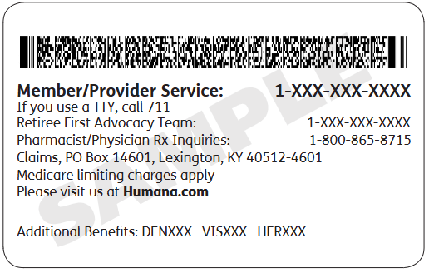
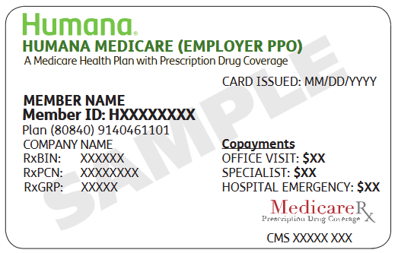

Disclaimer: For complete benefit details please refer to the carrier issued materials. This document includes a simplified summary of benefits and does not create any contractual rights.

