2026 – City of Salisbury Medicare Advantage with Prescription Drug Plan (MAPD)

Frequently Asked Questions

Plan Design
Medical Carrier:

Medical |  | You pay
Deductible |  | $0
Maximum Out of Pocket (MOOP) |  | $1200
Office Visit: Primary Care |  | $5
Office Visit: Specialist |  | $5
Inpatient Hospital Care |  | $0
Outpatient Hospital Care |  | $10
Skilled Nursing Facility |  | $0, Days 1-100
Emergency Room |  | $30, Waived if admitted within 24 hours
Urgent Care |  | $10, Waived if admitted within 48 hours
Ambulance Service |  | $20
Durable Medical Equipment |  | $0
Clinical Laboratory Services |  | $0
Preventative Screenings |  | $0
Chiropractic |  | $5 copay, up to 12 visits annually for routine services.
Acupuncture |  | $5 copay, up to 12 visits annually for routine services.
Podiatry |  | $0 copay, up to 12 visits annually for routine services.
Foreign Travel (World-wide) Coverage |  | $30 Emergency, $10 Urgent Care, $50,000 annual Max.
Hearing |  | $0 Routine Hearing Exam- 1 per year  $0 Fitting and Evaluations- 3 per year  $500- $1975 copay per ear depending on technology level of hearing aid.
Vision |  | $0 Routine Eye Exam, 1 per year  $100 Frame Allowance  $0 to $175 copay (depending on lens type)  $0 Medically Necessary Contact Lenses (In lieu of eyeglasses)  $100 Allowance Non- Medically Necessary Contact Lenses (in lieu of eyeglasses)
Dental |  | Annual Maximum - $1,250  Preventive & Diagnostic – 100%  Basic – 50%, after deductible  Major (Surgical & Restorative)– 50%, after deductible
Fitness Benefit |  | SilverSneakers

Prescription Carrier

Prescription | 30-day Retail  You pay up to |  | 90-day Retail  You pay up to | 90-day Mail Order  You pay up to
Annual Deductible: $0
Annual Maximum Out of Pocket (MOOP): $2,100
Tier 1-A Preferred Generic | $10 |  | $30 | $10
Tier 1 Generic | $10 |  | $30 | $10
Tier 2 Preferred Brand | $35 |  | $105 | $35
Tier 3 Non-Preferred Brand | $50 |  | $150 | $50
Tier 4 Specialty | $50 |  | N/A | N/A

Plan Questions

- How do I enroll in this plan?
To finalize your enrollment into the plan, the enclosed application and authorized representative form needs to be completed and returned to RetireeFirst in the included pre-paid envelope.

- Can I stay with the current plan?
No, all Medicare-eligible retirees and/or dependents must change over to this plan. Your current plan will no longer be available.

- Are there any plan changes?
The City of Salisbury did their best to match or enhance your current benefits. Below are a few highlights of your new plan:
- Moving to an all-in-one plan for Medical, Prescription, Dental and Vision coverage!
- Individual $50 Prescription deductible removed.
- Chiropractic, Acupuncture, and Podiatry coverage is now extended to both medically and non-medically necessary visits – Please see the Summary of Benefits or Evidence of Coverage sent directly from CareFirst for cost-sharing and limits.
- Includes a free fitness program: Silver Sneakers
- Includes In-Home Assessment (no cost to members)
- Includes 24/7 Nurse Advice Line (no cost to members)
- Includes Hearing Aid Coverage (copayments for various technologies and models)
- Access to RetireeFirst Advocates for assistance with understanding and using your benefits.
- When will I receive my ID card and welcome kit?
Cards and welcome kits should arrive in the month prior to your start date. Retirees and Medicare-eligible dependents will each receive their own card. Please note that each enrollee may not receive their plan information on the same day; this is normal.

- What do I do if I lose my card?
Please call RetireeFirst at (410) 202-2530 (TTY 711) or toll free at (855) 433-1670 (TTY 711) and we will obtain a new one on your behalf, mail you a temporary card, and call your pharmacy and/or providers if needed.

- If I leave the plan, will it affect any of my other benefits?
Yes, if you cancel or opt out of the City of Salisbury medical and drug coverage, you will also be waiving the City of Salisbury vision and dental benefits. Once you cancel coverage, you will not be able to re-enroll.

- How much do I have to pay for the plan?
The City of Salisbury can be reached at (410) 548-1065 to answer any billing questions.

- Who do I call if I need assistance with the plan?
Please call RetireeFirst at (410) 202-2530 (TTY 711) or toll free at (855) 433-1670 (TTY 711) to reach your dedicated City of Salisbury Retiree Advocacy Team, Monday-Friday, 8am-5pm, EST.

Medical Questions

- Is there a medical deductible?
No.

- Is there co-insurance or copays?
Some medical benefits are covered at 100% while others are subject to a copay amount. Please refer to your plan design details for more information.

- Does this plan require referrals?
No, this plan does not require referrals.

- Does this plan require pre-certifications?
Some services may require pre-certifications.

- Does this plan have a network?
Yes, but you can go to any willing Medicare provider, hospital, or facility. This plan’s in and out of network benefits are the same.

- Can I go to my current providers?
Most likely yes. You can see any provider that accepts Medicare and is willing to bill CareFirst.

- Do I still use my Medicare card?
No, put your Medicare card in a safe place in case you need it later. You will only use your CareFirst ID Card for medical and prescriptions.

- What if my provider says they do not accept this plan?
If your provider accepts Medicare, the portion you are responsible for will remain the same whether they are considered in or out of network. You can go to any willing Medicare provider, hospital, or facility. Please call RetireeFirst at (410) 202-2530 (TTY 711) or tollfree at (855) 433-1670 (TTY 711) to assist; we can reach out to your provider to explain.

Prescription Questions

- Is there a prescription deductible?
No.

- Is there co-insurance or copays?
Yes.

- Are my prescriptions covered?
Most likely yes, the prescription list is a comprehensive formulary just as before. Please call RetireeFirst at (410) 202-2530 (TTY 711) or toll free at (855) 433-1670 (TTY 711) if you need help looking up your prescriptions.

- Can I go to the same retail pharmacy?
Most likely, yes. There should be little to no pharmacy disruption. CareFirst has over 66,000 pharmacies in network. You do NOT need new prescriptions for retail pharmacy refills.

- Is there a mail order pharmacy?
There is a mail order pharmacy called CVS Caremark which can be reached at (888) 970-0917. You can also call RetireeFirst at (410) 202-2530 (TTY 711) or toll free at (855) 433-1670 (TTY 711) with questions about mail order prescriptions.

- Will my prescriptions transfer from the old plan?
If you use the retail pharmacy, and have refills remaining, you do NOT need to obtain new prescriptions. If you use mail order, you WILL need to obtain new prescriptions from your provider.

- Can I still go to the Veterans Affairs (VA) for my prescriptions?
Yes, if you obtain some prescriptions from the VA, you may continue to do so.

- Do I need prior authorizations for certain prescription medicines?
Some prescriptions may require a prior authorization. Please contact RetireeFirst at (410) 202-2530 (TTY 711) or toll-free at (855) 433-1670 (TTY 711) if you have questions or need assistance with prior authorizations as well as any other requirements such as step therapy, quantity limit, or formulary exceptions.

- What is the catastrophic phase and is there coverage?
The catastrophic phase is a phase of coverage designed to protect you from having to pay very high out-of-pocket costs for prescription drugs. It is the final phase in your prescription drug plan and your copays will be $0. You will remain in this phase for the rest of the plan year. This coverage phase kicks in when you reach a true out of pocket total of $2000 for prescription drugs. Keep in mind, lifestyle and non-part D prescription drugs do not count toward your out-of-pocket total.
- What is the annual maximum out-of-pocket (MOOP) and how does it work?
Once your out-of-pocket costs for prescription drugs reaches $2,100, your copays will be $0. You will remain in this phase of coverage for the rest of the plan year. Keep in mind, lifestyle and non-part D prescription drugs do not count toward your out-of-pocket total.

CareFirst Card Sample:

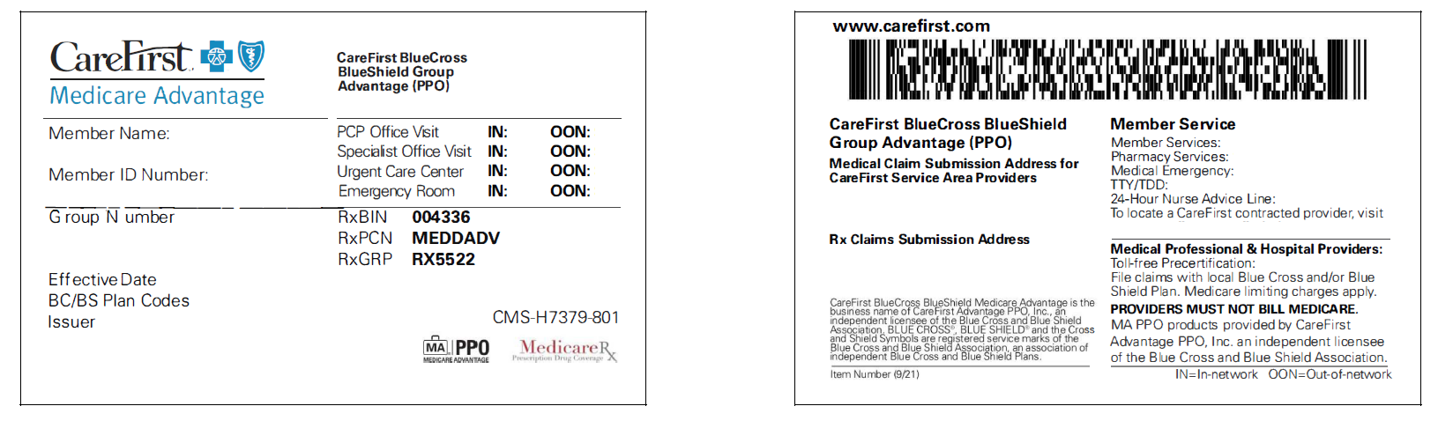
Front: Back:

Disclaimer: For complete benefit details please refer to the carrier issued materials. This document includes a simplified summary of benefits and does not create any contractual rights.

