
2026 – St. Mary’s County Public Schools Medicare Advantage with Prescription Drug Plan (MAPD)

Frequently Asked Questions

Plan Design
Medical Carrier:

Medical |  | You pay
Deductible |  | $0
Maximum Out of Pocket (MOOP) |  | $500
Office Visit: Primary Care |  | $15
Office Visit: Specialist |  | $15
Inpatient Hospital |  | $50 per admission
Outpatient Care |  | $10 per admission
Home Health Care |  | $0
Skilled Nursing Facility |  | $0
Emergency Room |  | $75
Urgent Care |  | $35
Ambulance Service |  | $20
Lab Services |  | $10
Radiology Services |  | $5/$10
Durable Medical Equipment |  | $0
Preventative Screenings |  | $0
Chiropractic |  | $15
Acupuncture |  | $15
Podiatry |  | $5 no more than 12 visits
Foreign Travel (World-wide) Coverage |  | Emergency & Urgent Care up to $50,000 maximum
Hearing |  | $0 routine exam
Vision |  | $0 routine exam (including dilations & refraction) from Davis provider
Dental |  | Covered thru CareFirst
Fitness Benefit |  | SilverSneakers

Prescription Carrier

Prescription | 30-day Retail  You pay up to |  | 90-day Retail  You pay up to | 90-day Mail Order  You pay up to
Annual Deductible: $0
Annual Maximum Out of Pocket (MOOP): $2,100

Tier 1 Preferred Generic | $10 |  | $20 | $10
Tier 2 Generic | $10 |  | $20 | $10
Tier 3 Preferred Brand | $15 |  | $30 | $15
Tier 4 Non-Preferred Brand | $15 |  | $30 | $15
Tier 5 Specialty | $15 |  | N/A | N/A

Plan Questions

- How do I enroll in this plan?
All Medicare-eligible retirees and/or dependents will be automatically enrolled into the plan. There is nothing you need to do to be enrolled.

We are required by law to give you the choice of opting out of the new plan. Since you are enrolled in the current medical and prescription drug plan it is unlikely that you would not want to participate in this new robust plan. However, you have the option to opt-out and decline this coverage. Nevertheless, if you would like to opt-out, please call RetireeFirst at 301.329.0004(TTY 711) or toll free 855.257.2550(TTY 711) Monday-Friday, 8am-5pm EST.

- Can I stay with the current plan?
No, all Medicare-eligible retirees and/or dependents must change over to this plan. Your current plan will no longer be available.

- When will I receive my ID card and welcome kit?
Cards and welcome kits should arrive in the month prior to your start date. Retirees and Medicare-eligible dependents will each receive their own card. Please note that each enrollee may not receive their plan information on the same day; this is normal.

- What do I do if I lose my card?
Please call RetireeFirst at 301.329.0004(TTY 711) or toll free 855.257.2550(TTY 711) and we will obtain a new one on your behalf, mail you a temporary card, and call your pharmacy and/or providers if needed.

- If I leave the plan, will it affect any of my other benefits?
Yes, it may.

- How much do I have to pay for the plan?
St. Mary’s County Public Schools Benefit Office 301-475-5511 ext. 32182 can be reached at 301-475-5511 ext. 32182 to answer any billing questions.
Years of SMCPS Service at Retirement | 10-19 | 20-29 | 30+
Medicare Advantage Premium¹ | $177.71 | $155.49 | $133.28
Dental Plan Premium | $ 12.09 | $ 10.59 | $ 9.07
Your Total Premium  (Medicare Advantage + Dental) | $189.80 | $166.08 | $142.35
¹ Medicare Advantage premium guaranteed for two years from January 1, 2025, through December 31, 2026 if benefits do not change.

- Who do I call if I need assistance with the plan?
Please call RetireeFirst at 301.329.0004(TTY 711) or toll free 855.257.2550(TTY 711) to reach your dedicated St. Mary’s County Public Schools Retiree Advocacy Team, Monday-Friday, 8am-5pm, EST.

Medical Questions

- Is there a medical deductible?
No, there is no medical deductible.

- Is there co-insurance or copays?
Yes, please see the above chart.

- Does this plan require referrals?
No, this plan does not require referrals.

- Does this plan require pre-certifications?
Some services may require pre-certifications.

- Does this plan have a network?
Yes, but you can go to any willing Medicare provider, hospital, or facility. This plan’s in and out of network benefits are the same.

- Can I go to my current providers?
Yes, you can see any provider that accepts Medicare and is willing to bill CareFirst.

- Do I still use my Medicare card?
No, put your Medicare card in a safe place in case you need it later. You will only use your CareFirst ID Card for medical and prescriptions.

- What if my provider says they do not accept this plan?
If your provider accepts Medicare, the portion you are responsible for will remain the same whether they are considered in or out of network. You can go to any willing Medicare provider, hospital, or facility. Please call RetireeFirst at 301.329.0004(TTY 711) or toll free 855.257.2550(TTY 711) to assist; we can reach out to your provider to explain.

Prescription Questions

- Is there a prescription deductible?
No, there is no prescription deductible.

- Is there co-insurance or copays?
Yes, please see the above chart.

- Are my prescriptions covered?
Most likely yes. The CareFirst BlueCross BlueShield Group Advantage Plan covers most Medicare Part d covered drugs as well as enhanced coverage for drugs not typically covered by Medicare (e.g. weight loss/gain, prescription vitamins, cold and cough). You can visit www.carefirst.com/learngroupma and click on Search Drugs to see if your drugs are covered. Please call RetireeFirst at 301.329.0004(TTY 711) or toll free 855.257.2550(TTY 711) if you need help looking up your prescriptions.

- Can I go to the same retail pharmacy?
Most likely, yes. There should be little to no pharmacy disruption. CareFirst has over 62,000 pharmacies in network. You do NOT need new prescriptions for retail pharmacy refills.

- Is there a mail order pharmacy?
There is a mail order pharmacy is called CVS Caremark which can be reached at 888.970.0917 EST. You can also call RetireeFirst at 301.329.0004(TTY 711) or toll free 855.257.2550(TTY 711) with questions about mail order prescriptions.

- Will my prescriptions transfer from the old plan?
If you use the retail pharmacy, and have refills remaining, you do NOT need to obtain new prescriptions. If you use mail order, you WILL need to obtain new prescriptions from your provider.

- Can I still go to the Veterans Affairs (VA) for my prescriptions?
Yes, if you obtain some prescriptions from the VA, you may continue to do so.

- Do I need prior authorizations for certain prescription medicines?
Some prescriptions may require a prior authorization. Please contact RetireeFirst 301.329.0004(TTY 711) or toll free 855.257.2550(TTY 711) at if you have questions or need assistance with prior authorizations as well as any other requirements such as step therapy, quantity limit, or formulary exceptions.

- What is the catastrophic phase and is there coverage?
The catastrophic phase is a phase of coverage designed to protect you from having to pay very high out-of-pocket costs for prescription drugs. It is the final phase in your prescription drug plan and your copays will be $0. You will remain in this phase for the rest of the plan year. This coverage phase kicks in when you reach a true out of pocket total of $2000 for prescription drugs.

- What is the annual maximum out-of-pocket (MOOP) and how does it work?
Once your out-of-pocket costs for prescription drugs reaches $2000, your copays will be $0. You will remain in this phase of coverage for the rest of the plan year. Keep in mind, lifestyle and non-part D prescription drugs do not count toward your out-of-pocket total.

CareFirst BlueCross BlueShield Group Advantage ID Card Sample:

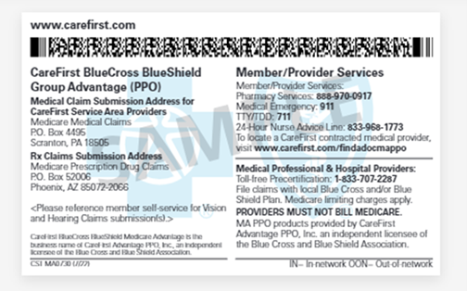
Front: Back:
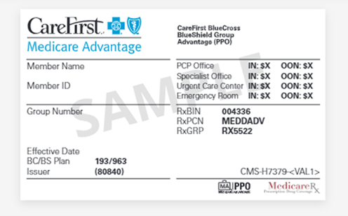

Disclaimer: For complete benefit details please refer to the carrier issued materials. This document includes a simplified summary of benefits and does not create any contractual rights.

