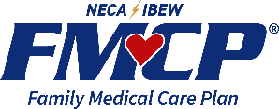
2026 – NECA IBEW Family Medical Care Plan UnitedHealthcare® Group Medicare Advantage PPO & Prescription Drug (MAPD) Plan with Sav-Rx Wrap

Frequently Asked Questions

Plan Design
Medical Carrier:

Medical |  | You pay
Deductible |  | $0
Maximum Out of Pocket (MOOP) |  | $1,800
Office Visit: Primary Care |  | $20
Office Visit: Specialist |  | $20
Inpatient Hospital |  | $0 per admit
Outpatient Care |  | $0
Home Health Care |  | $0
Skilled Nursing Facility |  | $0, Days 1-100
Emergency Room |  | $65, waived if admitted within 24 hrs
Urgent Care |  | $50, waived if admitted within 24 hrs
Ambulance Service |  | $0
Lab Services |  | $20
Radiology Services |  | $20
Durable Medical Equipment |  | $0
Preventative Screenings |  | $0
Chiropractic |  | $20, 12 visits per year
Acupuncture |  | $20, Medicare covered services only
Podiatry |  | $20, 6 visits per year
Foreign Travel (World-wide) Coverage |  | $65 Emergency Care and $50 Urgent Care – both waived if admitted within 24 hrs
Hearing (must use UHC Hearing) |  | $0 Routine Hearing Exam – 1 per year; $500 Hearing Aid Allowance – every 3 years
Vision |  | $0 Routine Eye Exam – 1 per year
Dental |  | Medicare covered services only
Fitness Benefit |  | SilverSneakers

Prescription Carrier


Prescription | 30-day Retail  You pay up  to |  | 90-day Retail  You pay up to | 90-day Mail Order  You pay up to
Annual Deductible: $0
Maximum Out of Pocket: $2,100
Tier 1 Generic | $0 | $0 |  | $0
Tier 2 Preferred Brand | 20% - Brands with Generics – Member pays difference | 20%-Brands with Generics – Member pays difference |  | 20% - Brands with Generics – Member pays difference
Tier 3 Non-Preferred Brand | 30% - $40 Min Brands with Generics – Member pays difference | 30% - $80 Min Brands with Generics – Member pays difference |  | 30% - $80 Min Brands with Generics – Member pays difference
Insulin Medications | $35 | $70 |  | $70

Plan Questions

- How do I enroll in this plan?
All Medicare-eligible retirees and/or dependents will be automatically enrolled into the plan. There is nothing you need to do to be enrolled.

We are required by law to give you the choice of opting out of the new plan. Since you are enrolled in the current medical and prescription drug plan it is unlikely that you would not want to participate in this new robust plan. However, you have the option to opt-out and decline this coverage. Nevertheless, if you would like to opt-out, please call RetireeFirst at 706.229.8769 (TTY 711) or toll free 855.220.9437 (TTY 711), Monday-Friday, 8am-5pm EST.

- When will I receive my ID card and welcome kit?
Cards and welcome kits should arrive in the month prior to your start date. Retirees and Medicare-eligible dependents will each receive their own card. Please note that each enrollee may not receive their plan information on the same day; this is normal.

- What do I do if I lose my card?
Please call RetireeFirst at 706.229.8769 (TTY 711) or toll free 855.220.9437 (TTY 711) and we will obtain a new one on your behalf, mail you a temporary card, and call your pharmacy and/or providers if needed.

- How much do I have to pay for the plan?
NECA IBEW Family Medical Care Plan Customer Service line can be reached at 877.937.9602 to answer any billing questions.

- Who do I call if I need assistance with the plan?
Please call RetireeFirst at 706.229.8769 (TTY 711) or toll free 855.220.9437 (TTY 711) to reach your dedicated NECA IBEW Family Medical Care Plan Retiree Advocacy Team, Monday-Friday, 8am-5pm, EST.

- Do I have any Ancillary benefits?
For any additional benefits available, please contact FMCP Customer Service Line at 877.937.9602.

Medical Questions

- Is there a medical deductible?
No, there is no medical deductible.

- Is there co-insurance or copays?
Yes, there are some copays for certain medical services. Please refer to the benefit chart beginning on page 1.

- Does this plan require referrals?
No, this plan does not require referrals.

- Does this plan require pre-certifications?
Some services may require pre-certifications.

- Does this plan have a network?
Yes, but you can go to any willing Medicare provider, hospital, or facility. This plan’s in and out of network benefits are the same.

- Can I go to my current providers?
Yes, you can see any provider that accepts Medicare and is willing to bill UnitedHealthcare®.

- Do I still use my Medicare card?
No, put your Medicare card in a safe place in case you need it later. You will only use your UnitedHealthcare® ID Card for medical services and your UnitedHealthcare® and Sav-Rx cards for prescriptions.

- What if my provider says they do not accept this plan?
If your provider accepts Medicare, the portion you are responsible for will remain the same whether they are considered in or out of network. You can go to any willing Medicare provider, hospital, or facility. Please call RetireeFirst at 706.229.8769 (TTY 711) or toll free 855.220.9437 (TTY 711) to assist; we can reach out to your provider to explain.

Prescription Questions

- Is there a prescription deductible?
No, there is no prescription deductible.

- Is there co-insurance or copays?
Yes, there are copays or co-insurance for prescriptions depending on the prescription tier. The cost share amounts can be found in the table beginning on page 3 of this document.

- Are my prescriptions covered?
Most likely yes, the prescription list is a comprehensive formulary just as before. Please call RetireeFirst at 706.229.8769 (TTY 711) or toll free 855.220.9437 (TTY 711) if you need help looking up your prescriptions.

- Can I go to the same retail pharmacy?
Most likely, yes. There should be little to no pharmacy disruption. UnitedHealthcare® has over 67,000 pharmacies in network. You do NOT need new prescriptions for retail pharmacy refills. You will need to show both your UnitedHealthcare® and Sav-Rx ID cards.

- Is there a mail order pharmacy?
Yes, Sav-Rx will be your dedicated Mail Order pharmacy.
- Ask your doctor to send the prescription(s) electronically to Sav-Rx in Fremont, NE or, ask your doctor to fax your prescription(s) to Sav-Rx at 402.753.2809.
- Call Sav-Rx with your prescription drug names, strength, and dosing along with your physician’s contact information. Sav-Rx will do the rest! Your dedicated Sav-Rx Member Service Telephone Number is 800.545.2810.
- Will my prescriptions transfer from the old plan?
If you use the retail pharmacy, and have refills remaining, you do NOT need to obtain new prescriptions. If you use mail order, you WILL need to obtain new prescriptions from your provider.

- Can I still go to the Veterans Affairs (VA) for my prescriptions?
Yes, if you obtain some prescriptions from the VA, you may continue to do so.

- Do I need prior authorizations for certain prescription medicines?
Some prescriptions may require a prior authorization. Please contact RetireeFirst at 706.229.8769 (TTY 711) or toll free 855.220.9437 (TTY 711) if you have questions or need assistance with prior authorizations as well as any other requirements such as step therapy, quantity limit, or formulary exceptions.

- What is the catastrophic phase and is there coverage?
The catastrophic phase is a phase of coverage designed to protect you from having to pay very high out-of-pocket costs for prescription drugs. It is the final phase in your prescription drug plan and your copays will be $0. You will remain in this phase for the rest of the plan year. This coverage phase kicks in when you reach a true out of pocket total of $2000 for prescription drugs. Under this plan, you’re out of pocket total is $1000.

UnitedHealthcare® Group Medicare Advantage PPO & Prescription Drug (MAPD) Plan Card Sample:

Front: Back:
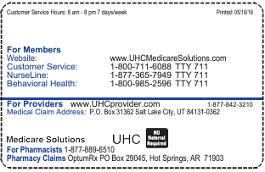
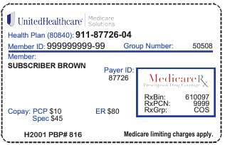

Sav-Rx Secondary Wrap Plan Card Sample

Front: Back:
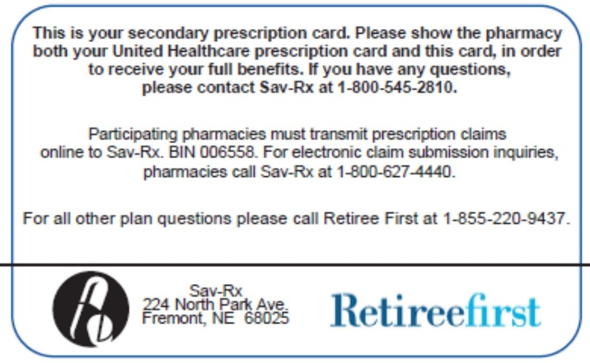
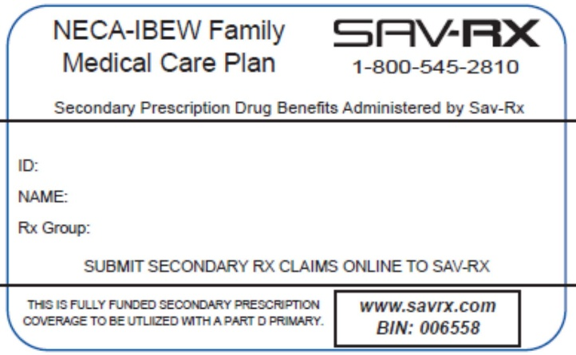

Disclaimer: For complete benefit details please refer to the carrier issued materials. This document includes a simplified summary of benefits and does not create any contractual rights.

